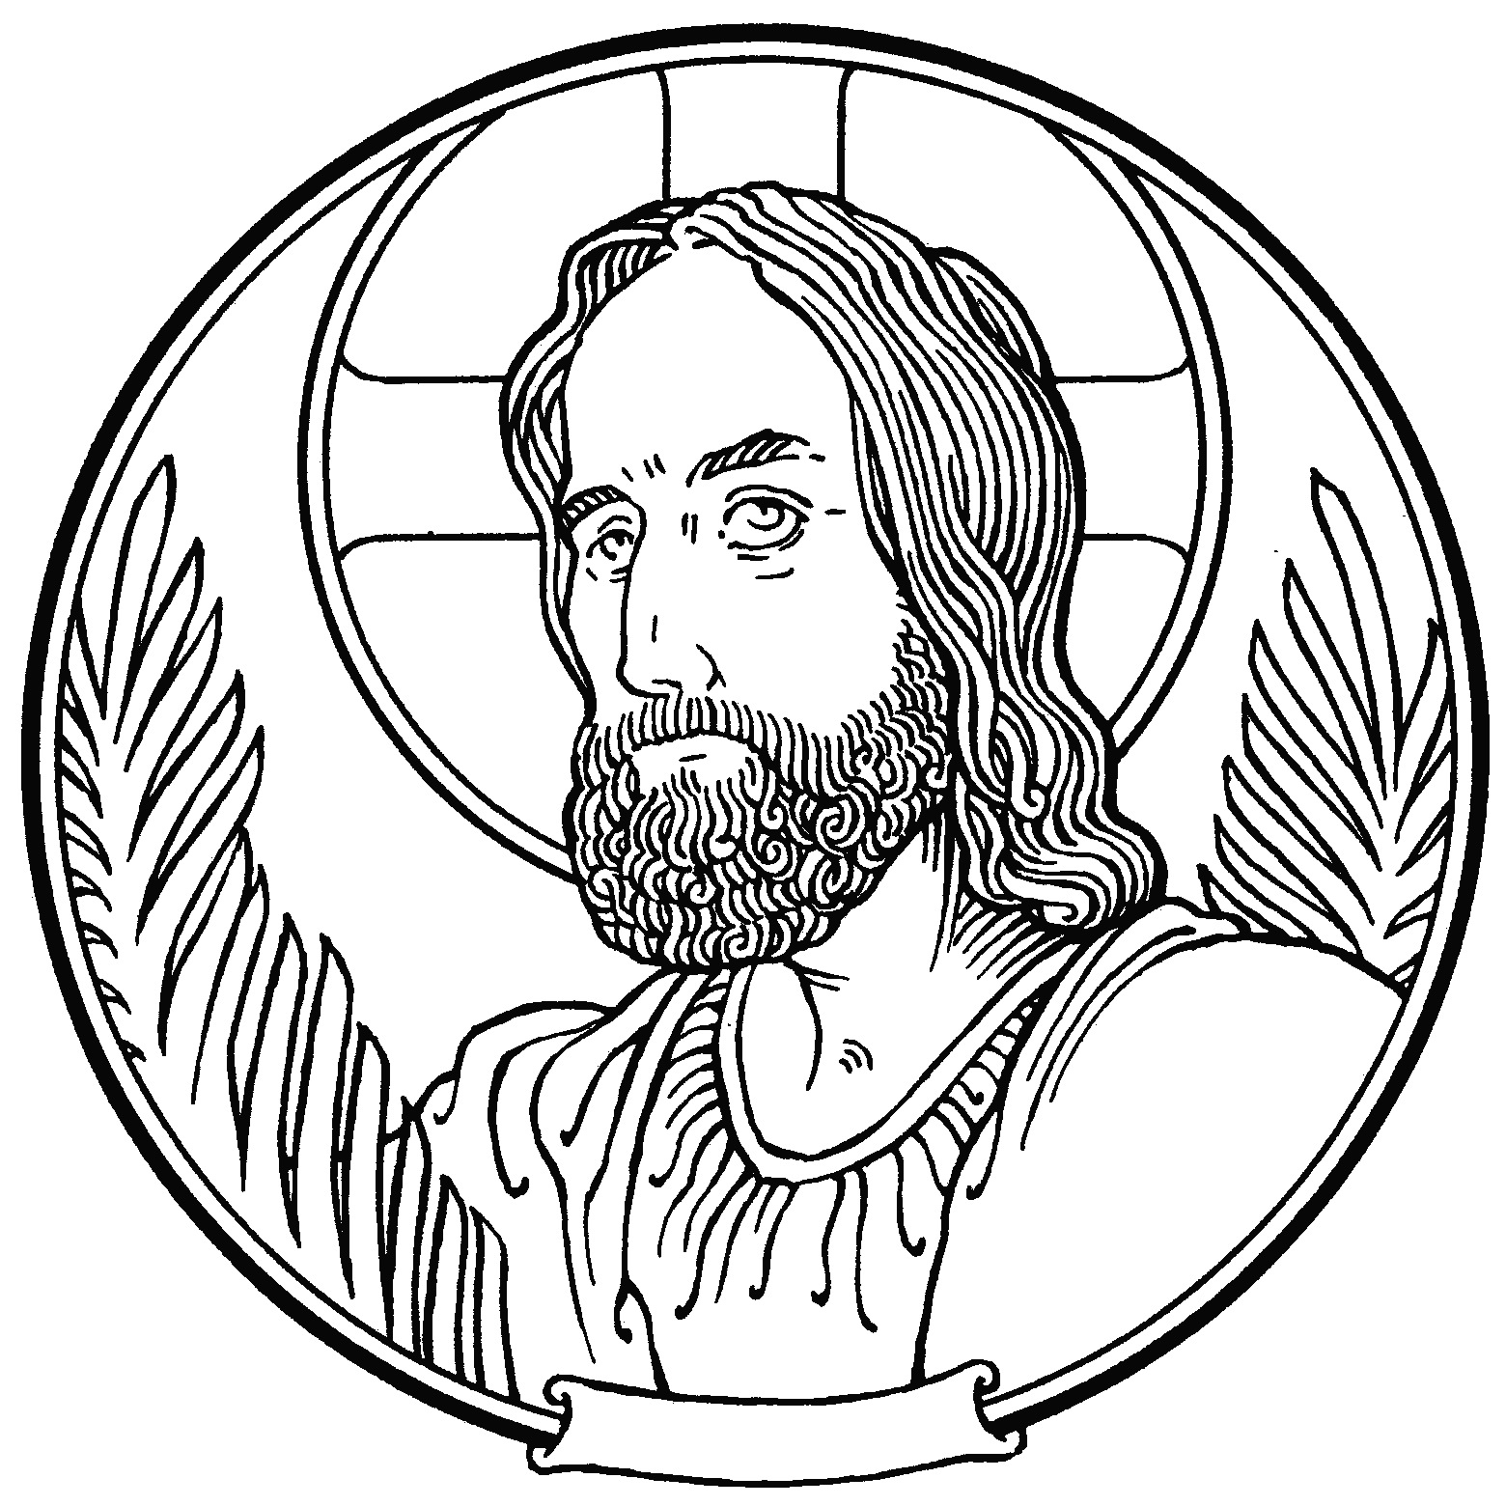
Zion Lutheran Church

The Divine Service

First Sunday in Advent

Welcome

Before Service Prayer

The four-week season of Advent opens the Church Year and prepares us for Christmas. During the Sundays in Advent, familiar symbols and Scripture readings bring us “the bad news and the good news.” On the one hand, they sharpen our sense of unworthiness and need for redemption. On the other, they stir in us an eager expectation for our promised Savior. Advent’s somber side reflects its message of repentance: “Prepare to meet your Maker!” Advent’s joyful side reflects its message of grace: “Prepare to receive God’s gift – Himself!” Preparation for “Xmas” – the commercial Christmas holiday – usually means hectic planning and much activity. But Advent’s preparation for Jesus’ birthday means time-out and quiet moments. “Xmas” preparation may be a dreaded burden with high emotional expectations that are seldom met. But Advent’s preparation is God’s work, cleansing our minds, setting our hearts at peace, and fulfilling our inmost longings. This Advent, let God speak to you and satisfy your need for deeply-felt celebration.

King Schoenfeld, Advent, 1996

Almighty, eternal, just and merciful God, give us miserable ones the grace to do for You alone what we know you want us to do and always to desire what pleases You. Inwardly cleansed, interiorly enlightened and inflamed by the fire of the Holy Spirit, may we be able to follow in the footsteps of Your beloved Son, our Lord Jesus Christ and, by Your grace alone, may we make our way to You, Most High, who live and rule in perfect Trinity and simple Unity, and are glorified God almighty, forever and ever. Amen.

St. Francis of Assisi

November 27, 2022 T 10:00 AM
We are very happy that you are here today!
At Zion, the bulletin and Lutheran Service Book (LSB) are both used to lead us through our worship. To help guide you during the service, below are some helpful tips.

- For each section of the Divine Service, the page number in the hymnal is listed in the bulletin on the right side of the page, i.e., LSB 184, which is found towards the front of the hymnal. All responses are sung unless they are printed in the bulletin.
- P indicates sections spoken by the Pastor. C indicates responses by the Congregation and will be in bold print.
- All hymns are listed in the bulletin with the name of the hymn and page number, i.e., Thy Strong Word LSB 578. They are also shown on the Hymn board at the front of the church.
- The bold, italic text in both the bulletin and the hymnal shows when the congregation should stand or sit during the Divine Service. The Pastor may also provide direction.

A Special Welcome to Those with Young Children
At Zion we want families with children to feel at home.

- First, please relax and enjoy your time here. Jesus knows that children tend to wiggle and squawk a bit, so please don’t feel embarrassed by it. Your children are welcome at Zion.
  - To make it a bit easier on your family, please dare to sit toward the front where your children can easily see the front of the Church, note the colors, watch the pastor, wonder about the stained-glass windows above the altar and embrace the action at the altar. What Jesus does here promises to engage them.
- As we go, softly explain the Liturgy to your children, encouraging them to chime in on their parts: Amen! Lord have mercy! And with thy Spirit! I believe! Our Father! All of that belongs to them too.
  - Be sure to sing and say and pray your parts too as you stand and sit. Your children learn by following your lead.
  - If you and your child must leave, please hurry back. We want you and your children here very much.
  - If you need a little help, just ask. There are lots of folks here who will lend you a hand.
  - Please know that while you are caring for your children, the rest of us will be rejoicing in Jesus’ words, “Let the little children come to me and do not hinder them, for the kingdom of God belongs to such as these” (Luke 18:16).

We know that your children are a gift to the Church, so we will do our best to welcome, smile, encourage, help, and bless you all. Welcome to Zion!

Divine Service, Setting Three

The Preparation
Processional Hymn Christ Is Our Cornerstone LSB 912

Stand

Invocation LSB 184

Rite of Holy Baptism – Theodore Edward Morrison LSB 268-271

Service of the Word

Introit Psalm 25:4–5, 21–22; antiphon: vv. 1–3a
P To you, O Lord, I lift | up my soul.*
O my God, in you I trust; let me not be | put to shame.
C Let not my enemies exult | over me.*
Indeed, none who wait for you shall be | put to shame.
P Make me to know your ways, | O Lord;*
teach me | your paths.
C Lead me in your truth and teach me, for you are the God of my sal- | vation;*
for you I wait all the | day long.
P May integrity and uprightness pre- | serve me,*
for I | wait for you.
C Redeem Israel, | O God,*
out of all his | troubles.
C Glory be to the Father and | to the Son*
and to the Holy | Spirit;
as it was in the be- | ginning,*
is now, and will be forever. | Amen.
P To you, O Lord, I lift | up my soul.*
O my God, in you I trust; let me not be | put to shame.
C Let not my enemies exult | over me.*
Indeed, none who wait for you shall be | put to shame.

Kyrie LSB 186

Salutation and Collect of the Day LSB 189

P The Lord be with you.
C And with thy spirit.

P Let us pray.

Stir up Your power, O Lord, and come, that by Your protection we may be rescued from the threatening perils of our sins and saved by Your mighty deliverance; for You live and reign with the Father and the Holy Spirit, one God, now and forever.

C Amen.

Sit

Old Testament Reading Isaiah 65:17-25
The Old Testament Reading for The First Sunday in Advent is from Jeremiah, the twenty-third chapter.
“Behold, the days are coming, declares the Lord, when I will raise up for David a righteous Branch, and he shall reign as king and deal wisely, and shall execute justice and righteousness in the land. In his days Judah will be saved, and Israel will dwell securely. And this is the name by which he will be called: ‘The Lord is our righteousness.’
“Therefore, behold, the days are coming, declares the Lord, when they shall no longer say, ‘As the Lord lives who brought up the people of Israel out of the land of Egypt,’ but ‘As the Lord lives who brought up and led the offspring of the house of Israel out of the north country and out of all the countries where he had driven them.’ Then they shall dwell in their own land.”

P This is the Word of the Lord.
C Thanks be to God.

Gradual Psalm 25:3-4
P None who wait for you shall be put to shame;
they shall be ashamed who are wantonly treacherous.
C Make me to know your ways, O Lord;
teach me your paths.

Epistle Reading Romans 13:11-14
The Epistle Reading is from Romans, the thirteenth chapter.

Besides this you know the time, that the hour has come for you to wake from sleep. For salvation is nearer to us now than when we first believed. The night is far gone; the day is at hand. So then let us cast off the works of darkness and put on the armor of light. Let us walk properly as in the daytime, not in orgies and drunkenness, not in sexual immorality and sensuality, not in quarreling and jealousy. But put on the Lord Jesus Christ, and make no provision for the flesh, to gratify its desires.

P This is the Word of the Lord.
C Thanks be to God.

Stand

Alleluia LSB 190

Holy Gospel Matthew 21:1-9
P The Holy Gospel according to St. Matthew, the twenty-first chapter.
C Glory be to Thee, O Lord.

When they drew near to Jerusalem and came to Bethphage, to the Mount of Olives, then Jesus sent two disciples, saying to them, “Go into the village in front of you, and immediately you will find a donkey tied, and a colt with her. Untie them and bring them to me. If anyone says anything to you, you shall say, ‘The Lord needs them,’ and he will send them at once.” This took place to fulfill what was spoken by the prophet, saying,
“Say to the daughter of Zion,
‘Behold, your king is coming to you,
humble, and mounted on a donkey,
and on a colt, the foal of a beast of burden.’”
The disciples went and did as Jesus had directed them. They brought the donkey and the colt and put on them their cloaks, and he sat on them. Most of the crowd spread their cloaks on the road, and others cut branches from the trees and spread them on the road. And the crowds that went before him and that followed him were shouting, “Hosanna to the Son of David! Blessed is he who comes in the name of the Lord! Hosanna in the highest!”

P This is the Gospel of the Lord.
C Praise be to thee, O Christ.

Nicene Creed
C I believe in one God,
the Father Almighty,
maker of heaven and earth
and of all things visible and invisible.

And in one Lord Jesus Christ,
the only-begotten Son of God,
begotten of His Father before all worlds,
God of God, Light of Light,
very God of very God,
begotten, not made,
being of one substance with the Father,
by whom all things were made;
who for us men and for our salvation came down from heaven
and was incarnate by the Holy Spirit of the virgin Mary
and was made man;
and was crucified also for us under Pontius Pilate.
He suffered and was buried.
And the third day He rose again according to the Scriptures
and ascended into heaven
and sits at the right hand of the Father.
And He will come again with glory to judge both the living and the dead,
whose kingdom will have no end.

And I believe in the Holy Spirit,
the Lord and giver of life,
who proceeds from the Father and the Son,
who with the Father and the Son together is worshiped and glorified,
who spoke by the prophets.
And I believe in one holy Christian and apostolic Church,
I acknowledge one Baptism for the remission of sins,
and I look for the resurrection of the dead
and the life T of the world to come. Amen.

Children’s Message

Hymn of the Day The Advent of Our King LSB 331

Sermon Tears of Sadness and Joy: The Race of Faith All Readings

Offertory LSB 192

Prayer of the Church
P Lord in Your Mercy,
C Hear our Prayer

Service of the Sacrament
Preface LSB 194
Proper Preface
Sanctus LSB 195
Lord’s Prayer LSB 196

The Words of Our Lord LSB 197
Pax Domini LSB 197
Agnus Dei LSB 198

Distribution
We at Zion Lutheran Church of Augsburg believe and confess along with the Holy Scriptures, that this bread and wine in the Sacrament of Holy Communion are truly the body and blood of our Lord Jesus Christ, instituted by Christ Himself, for us Christians to eat and drink. The gifts of His physical body and blood are given in, with, and under the elements of bread and wine at the altar. Those who are communicant members of a Lutheran Church—Missouri Synod congregation are welcome to commune at this altar with us. Other guests wishing to join our confession and receive this Holy Sacrament are invited to meet with the Pastor for Catechesis before communing. Anyone not communing may still come forward, crossing their arms at the rail, to receive a blessing from the Pastor.

The apostle Paul encourages everyone coming to the Sacrament to examine him/herself (1 Corinthians 11:28-29). Ask yourself the following questions: 1) Are you aware that you are a sinner; and, are you sorry for your sins? 2) Do you believe in Jesus Christ as your Savior and Lord and in His words of promise in the Sacrament: “This is my body,” "This is my blood”? 3) Also, do you intend with the help of the Holy Spirit to live as a forgiven, redeemed child of God, resisting the devil, saying no to sinful desires, and walking in the new life God provides?

Communion Hymn Your Table I Approach LSB 628

Communion Hymn Almighty God, Your Word Is Cast LSB 577

Communion Hymn Be Present At Our Table, Lord LSB 775

Nunc Dimittis LSB 199
Thanksgiving LSB 200
Post-Communion Collect LSB 201
Salutation, Benedicamus, and Benediction
Sit

Recessional Hymn Oh Savior, Rend the Heavens Wide LSB 355

T Soli Deo Gloria T

Serving in the Divine Service

PREACHER
Rev. Joshua Ralston, Pastor

ORGANIST
Dennis Steuber

ACOLYTE
Linton Dorn, Gavin Rion

USHERS
Dave Boswell, Rusty Dorn, Robert Sims

ALTAR GUILD
Wanda Choate, Delores McDaniel

ELDER
Joe Grant

TRUSTEE
Dave Boswell

SERVING IN DECEMBER:

ACOLYTE
Linton Dorn, Gavin Rion

USHERS
Dave Boswell, Rusty Dorn, Robert Sims

ALTAR GUILD
Wanda Choate, Delores McDaniel

ELDER
Joe Grant

TRUSTEE
Dave Boswell

The Prayers of the Church

Persecuted Christians in:
Jordan
Nepal
Butan
Kazakhstan
United Arab Emirates

Partner Church
Evangelical Lutheran Church of Haiti

Comfort, Health, and Recovery
Tom Battaglia (friend of Ron Hairston)
Jonathan Henshel (friend of Katie Villalobos)
Tina Found (friend of Katie Villalobos)
Joyce Mendenhall (friend of Susan Colles)
Debbie Swindell (friend of Phyllis Campbell)
Frank Russenberger
Suzan Steuber (mother of Angela Waldo)
Korey Heath (friend of Zoe Ward)
Connie Ragsdale (relative of Diane Ragsdale & Angela Waldo)
Rick Shott
Lucas Bachman (student of Katie Villalobos)
Mildred Greathouse (grandmother of Tony Waldo)
Kristen Brown (friend of Earl Schrock)

Continued Prayers
Landell Aday (friend of Greg Kremers)
Josh Dodson (brother of Tasha Schlittenhart)
Elizabeth Sharp, Amber Beatty, Tami Robinson (friends of Phyllis Campbell)
Tracy Boswell (sister-in-law of Barbara Smith)
Ashton Schrock (relative of Earl Schrock)
Alissa Wicker & Jace (friends of Katie Villalobos)
Jesse Lea (brother of Wanda Choate)
Keith Olson (nephew of Linda Shott)

Homebound
Dorothy Birkhahn
Betty Bocksnick
Nettie Grant
Gwen Hale
Helen Riek
Glenda Schrock

Serving in the armed forces
Matthew Allen
Brian Rutledge
Trent Hale
Josh Imme
Dale Ozment
Hunter Greenfield
Abigail Manuel

When hospitalized, sick, needing prayer or absolution,
contact Pastor Ralston anytime at 501-454-0581.

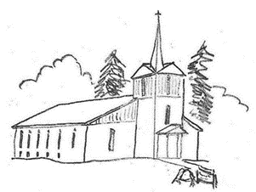
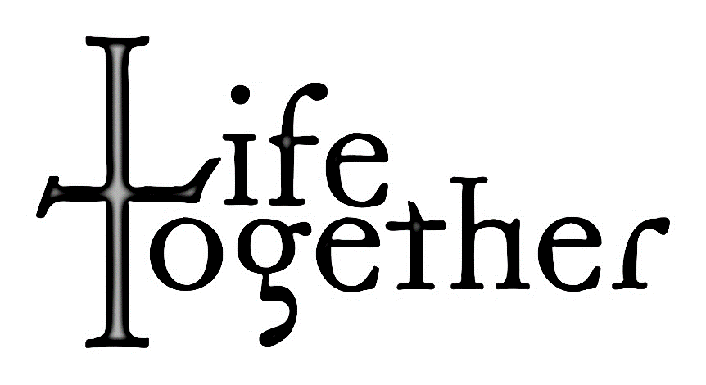

ZION

Advent is Coming!
The first mid-week Advent service will be this Wednesday, November 30th! Our series “Enough to Learn for a Lifetime” will explore the extraordinary gift of new birth and new life we’re given through the Sacrament of Holy Baptism!

Advent Soup Suppers
Come early and enjoy delicious food and fellowship before all Advent services! The meal will begin at 5:45. Sign up in the Narthex to provide soup, bread, or dessert.

Christmas Play Practice
All children participating in the Christmas Program will begin practice Wednesday, November 30th at 6:00 P.M. Be sure to come at 5:45 P.M. to eat soup before practice!

Voters Meeting and Potluck
There is a voters meeting and potluck coming up! On December 11th, we will meet after service. Make sure to be there as we will vote in officers and a budget for 2023.

The Last Day of
the Church Year
November 20, 2022
The Fruits of Our Faith 11/13/2022
Worship Attendance: 77
Children’s Sunday School: 5
Adult Sunday School: 17

General Fund: $ 1,685.15
Weekly Need: $ 2,870.00

Food Pantry: $ 370.00

Christmas Eve and Christmas
Day Church Schedule
On Christmas Eve, the Children’s play will begin at 6:00 PM. Afterwards, there will be a reception downstairs. The Christmas Eve Candlelight service will begin at 7:30 PM.

On Christmas Day, there will be no Sunday School for Adults or children. Divine Service will be at its normal 10:00 AM time.

Zion
Lutheran Church
93 Augsburg Rd
London, AR 72847
PO Box 327
Dover, AR 72837
479-331-3277

The Reverend Joshua Ralston
Pastor
Rusty Dorn
Congregational President
Jeff Schlittenhart
Head Elder
Diane Ragsdale
LWML President
Eunice LaMar
Treasurer
Phyllis Campbell
Office Assistant
Email: rev.jralston@gmail.com
Website: zionaugsburg.org
Facebook: facebook.com/ AugsburgZionLutheranChurch

If calling for a Pastoral Emergency, contact Pastor Ralston directly:
Cell…………...……..501-454-0581
Church……..........479-331-3277

Restrooms
Restrooms are located in the Narthex outside of the Sanctuary and in the basement Fellowship Hall. Please see an usher if you need assistance.
Nursery
The Nursery is located in the Narthex outside of the Sanctuary.
Congregational Membership
New members are received by Baptism, Confirmation, Transfer, or Profession of Faith (after receiving Pastoral instruction). Please speak with Pastor Ralston for more details.
Pastoral Consultation
Pastoral Consultation based on the Holy Scriptures is available from the Pastor. Please speak with Pastor Ralston to make an appointment.
Sick and Homebound
The sick and homebound are visited regularly by the Pastor with the Scriptures and Sacrament. Please contact Pastor Ralston if you know of any parishioner in need of pastoral visitation.
Pastor’s Bible Study, Teen, and Children’s Sunday School
Sunday School begins at 9:00 a.m. Anyone from confirmation age on up is welcome to attend Bible Study. Teen and Children’s Sunday School is held every Sunday in the basement Fellowship Hall/Family Center (Ages 0 and up).
Listen to Lutheran Radio
Listen: Issues, Etc. is talk-radio for the thinking Christian. Listen 24/7 at www.IssuesETC.org The Lutheran Hour is broadcast on KARV 610 AM/101.3 FM every Sunday at 7:30AM.

