Zion Lutheran Church

The Divine Service

Quinquagesima

Welcome

We need to know that Christ’s work of driving out the devil never ceases but continues to go on in the Christian world until the Last Day. Wherever Christ’s kingdom is, his wondrous work continues, causing the dumb to speak, the blind to see, and the deaf to hear. When Christ came into the flesh, he set this work going, and it continues in Christendom day for day till the world’s end. For this task Christ left us designated instruments: holy baptism, the blessed Sacrament, the Word and absolution, and whatever else belongs to the ministry of preaching, in order to enable us to destroy the devil’s kingdom, to take from him his captives and cast him out of people. That promise is written in Isaiah 55:11: Verbum dei non redibit vacuum. [The Word of God shall not return void]. Just as rain fructifies the dry land, causing it to become green and alive, so God’s Word produces fruit wherever it comes. The Holy Spirit accompanies the Word, to enlighten, kindle faith, cleanse, and free people from the devil’s power and rule.

Martin Luther, "Sermon for Oculi, Third Sunday
in Lent," in The House Postils, Vol 1, P. 330
Before Service Prayer

Jesus, Son of David, have mercy on me!
Let me see You clearly and confess You truly. Amen.

Lutheran Study Bible, p. 1755, fn.18:35-43

February 14th, 2021
We are very happy that you are here today!
At Zion, the bulletin and Lutheran Service Book (LSB) are both used to lead us through our worship. To help guide you during the service, below are some helpful tips.

- For each section of the Divine Service, the page number in the hymnal is listed in the bulletin on the right side of the page, i.e., LSB 184, which is found towards the front of the hymnal. All responses are sung unless they are printed in the bulletin.
- P indicates sections spoken by the Pastor. C indicates responses by the Congregation and will be in bold print.
- All hymns are listed in the bulletin with the name of the hymn and page number, i.e., Thy Strong Word LSB 578. They are also shown on the Hymn board at the front of the church.
- The red text in both the bulletin and the hymnal shows when the congregation should stand or sit during the Divine Service. The Pastor may also provide direction.

A Special Welcome to Those with Young Children
At Zion we want families with children to feel at home.

- First, please relax and enjoy your time here. Jesus knows that children tend to wiggle and squawk a bit, so please don’t feel embarrassed by it. Your children are welcome at Zion.
  - To make it a bit easier on your family, please dare to sit toward the front where your children can easily see the front of the Church, note the colors, watch the pastor, wonder about the stained-glass windows above the altar and embrace the action at the altar. What Jesus does here promises to engage them.
- As we go, softly explain the Liturgy to your children, encouraging them to chime in on their parts: Amen! Lord have mercy! And with thy Spirit! I believe! Our Father! All of that belongs to them too.
  - Be sure to sing and say and pray your parts too as you stand and sit. Your children learn by following your lead.
  - If you and your child must leave, please hurry back. We want you and your children here very much.
  - If you need a little help, just ask. There are lots of folks here who will lend you a hand.
  - Please know that while you are caring for your children, the rest of us will be rejoicing in Jesus’ words, “Let the little children come to me and do not hinder them, for the kingdom of God belongs to such as these” (Luke 18:16).

We know that your children are a gift to the Church, so we will do our best to welcome, smile, encourage, help and bless you all. Welcome to Zion!

Divine Service, Setting Three
The Preparation

Processional Hymn Lord Jesus Christ, Be Present Now LSB 902

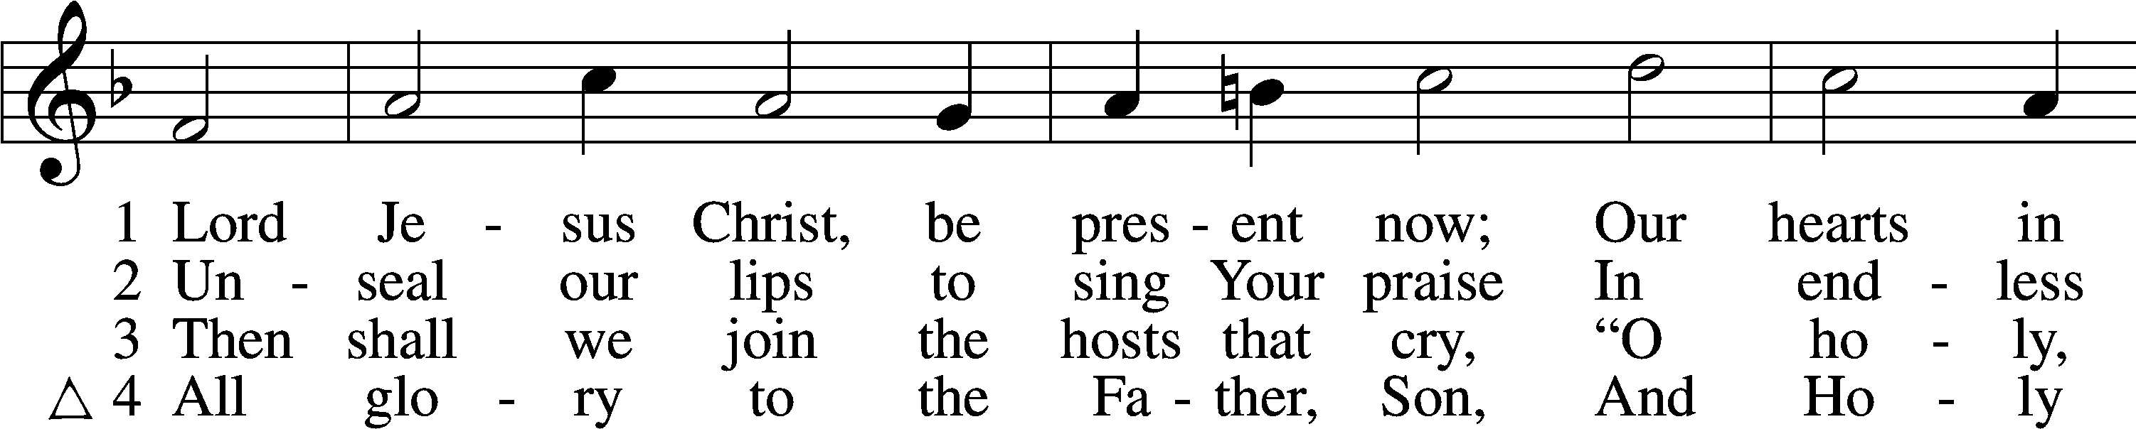
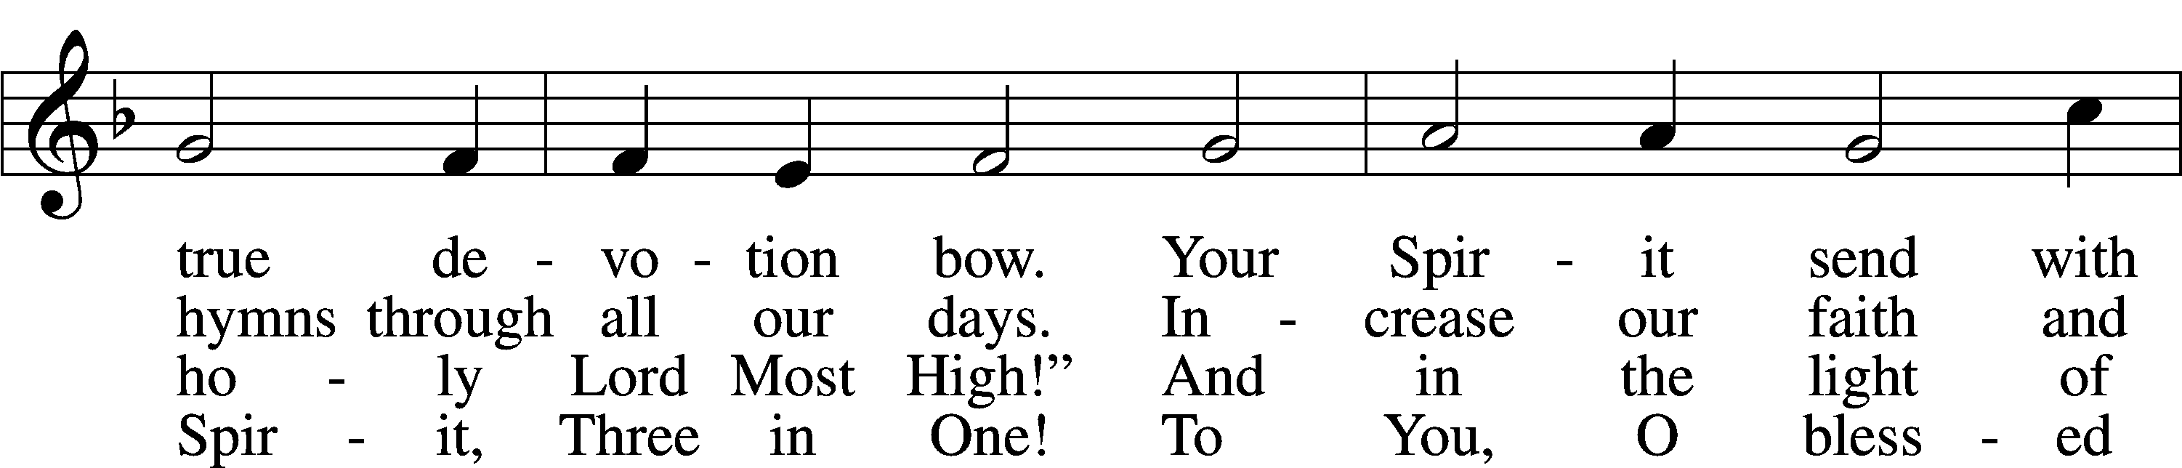
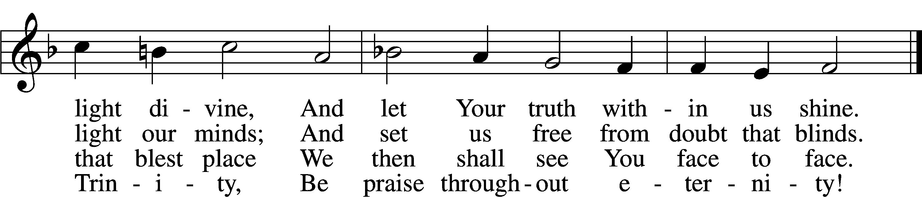
Tune and text: Public domain

Stand

Invocation

P In the name of the Father and of the T Son and of the Holy Spirit.
C Amen.

Confession of Sins and Absolution

P Beloved in the Lord! Let us draw near with a true heart and confess our sins unto God our Father, beseeching Him in the name of our Lord Jesus Christ to grant us forgiveness.

P Our help is in the name of the Lord,

C who made heaven and earth.
P I said, I will confess my transgressions unto the Lord,
C and You forgave the iniquity of my sin.

Silence for reflection on God’s Word and for self-examination.

P O almighty God, merciful Father,

C I, a poor, miserable sinner, confess unto You all my sins and iniquities with which I have ever offended You and justly deserved Your temporal and eternal punishment. But I am heartily sorry for them and sincerely repent of them, and I pray You of Your boundless mercy and for the sake of the holy, innocent, bitter sufferings and death of Your beloved Son, Jesus Christ, to be gracious and merciful to me, a poor, sinful being.

P Upon this your confession, I, by virtue of my office, as a called and ordained servant of the Word, announce the grace of God unto all of you, and in the stead and by the command of my Lord Jesus Christ I forgive you all your sins in the name of the Father and of the T Son and of the Holy Spirit.

C Amen.
Service of the Word
Introit Psalm 31:1, 5, 9, 16; antiphon: vv. 2b–3

P Be a rock of ref- | uge for me,*
a strong fortress to | save me!
C For you are my rock and my | fortress;*
and for your name’s sake you lead me and | guide me.
P In you, O Lord, do I take refuge; let me never be | put to shame;*
in your righteousness de- | liver me!
C Into your hand I commit my | spirit;*
you have redeemed me, O Lord, | faithful God.
P Be gracious to me, O Lord, for I am | in distress;*
my eye is wasted from grief; my soul and my body | also.
C Make your face shine on your | servant;*
save me in your | steadfast love!
C Glory be to the Father and | to the Son*
and to the Holy | Spirit;
as it was in the be- | ginning,*
is now, and will be forever. | Amen.
P Be a rock of ref- | uge for me,*
a strong fortress to | save me!
C For you are my rock and my | fortress;*
and for your name’s sake you lead me and | guide me.

Kyrie LSB 186
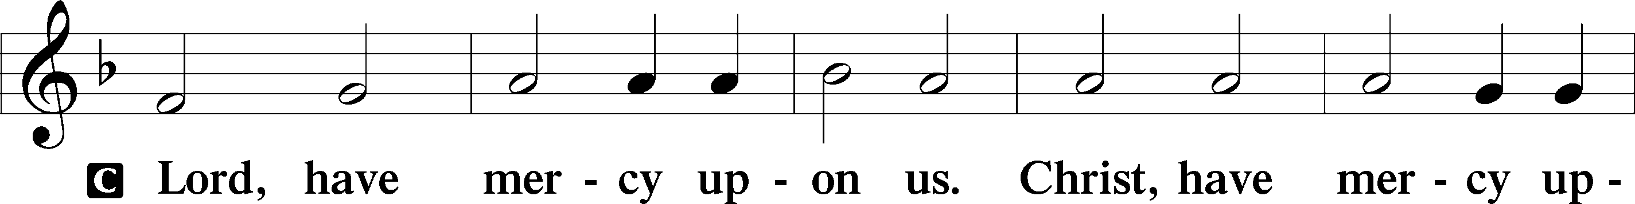
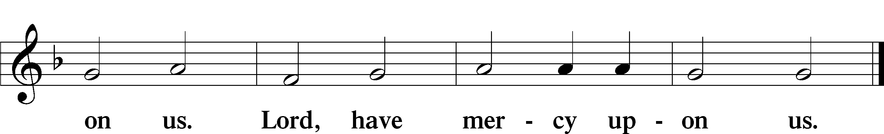

Gloria in Excelsis LSB 187
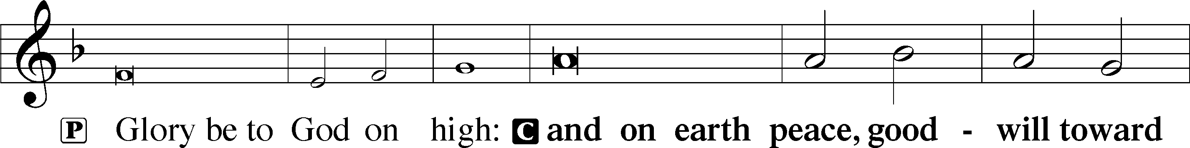
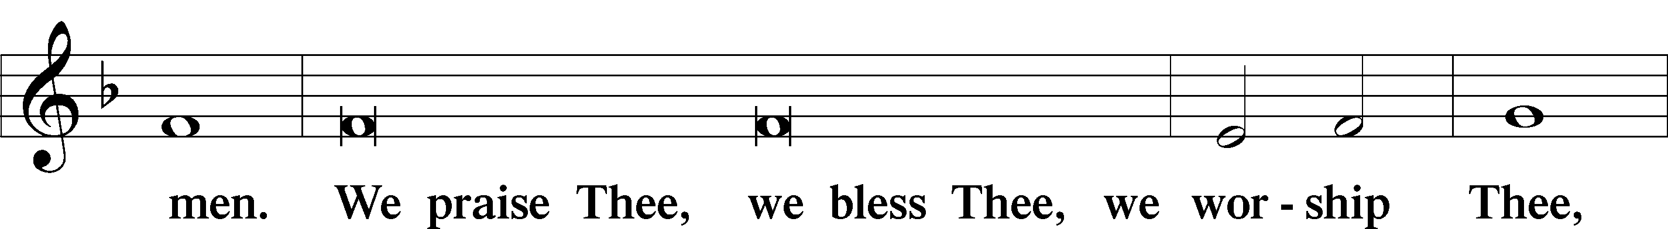
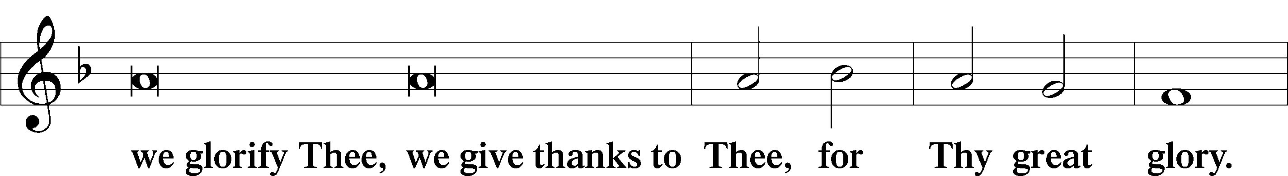
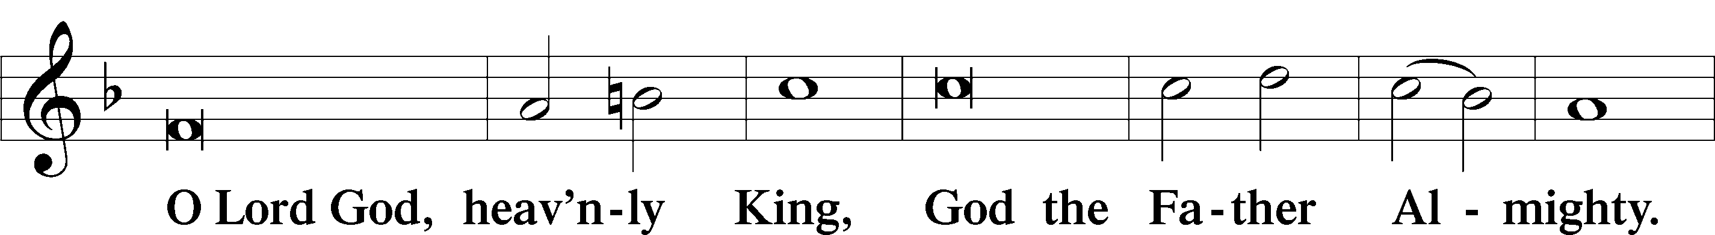
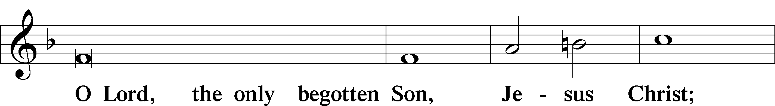
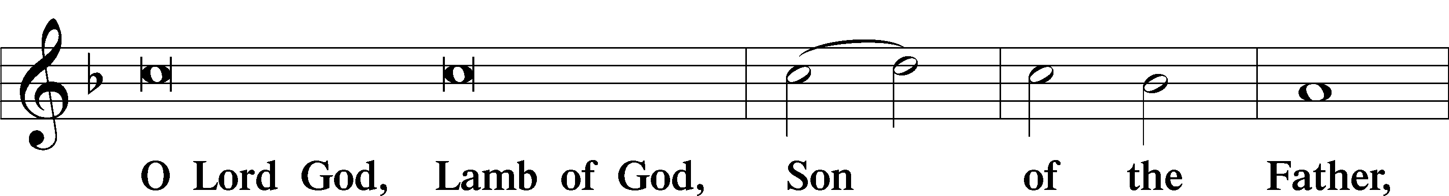
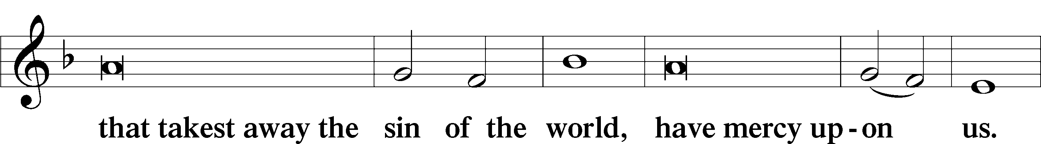
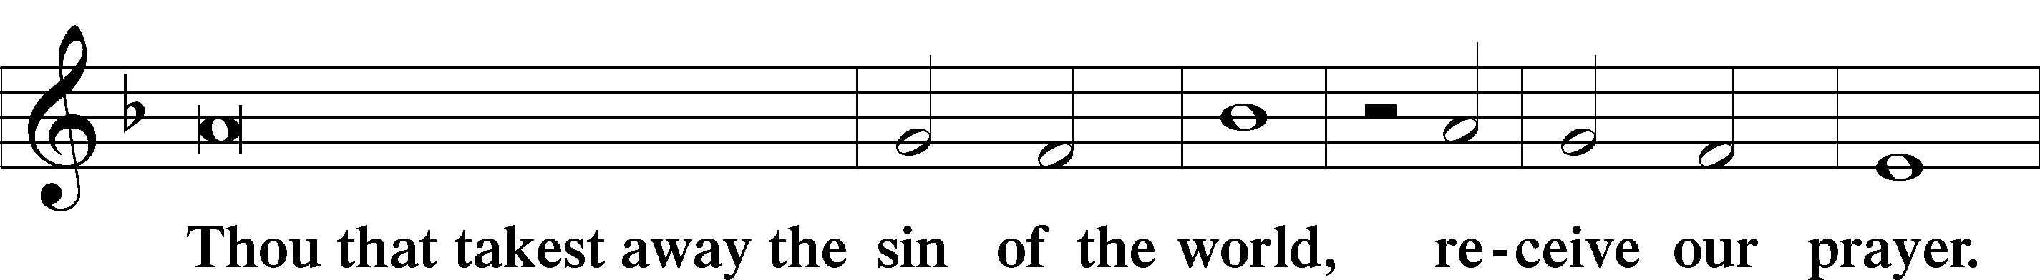
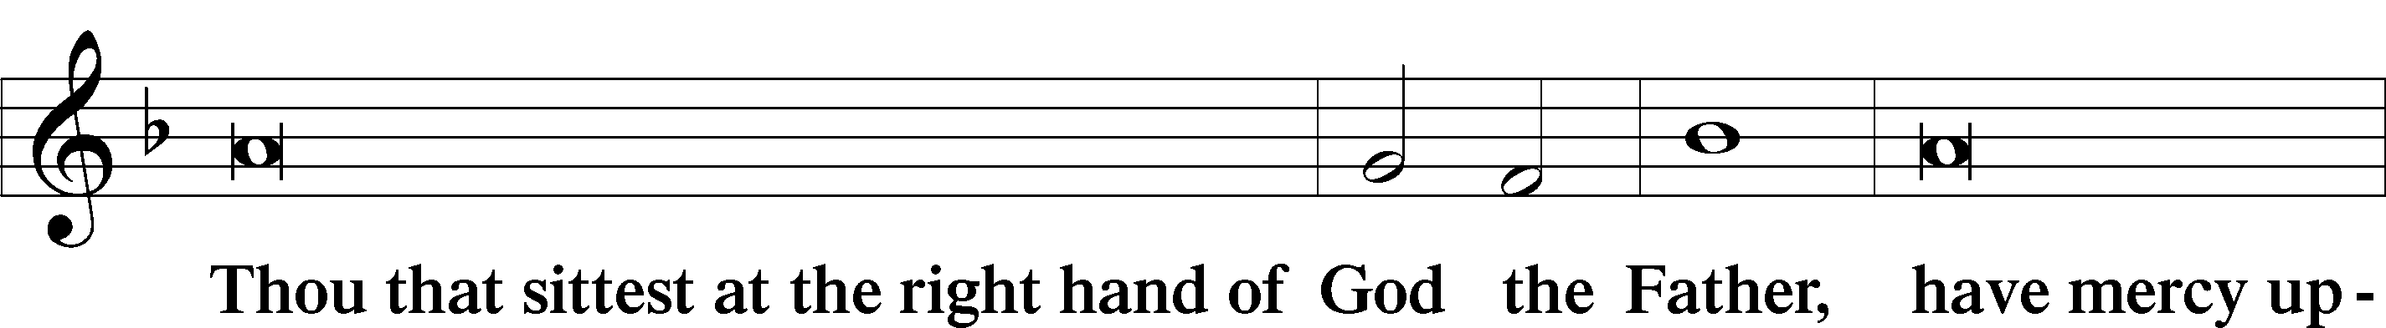
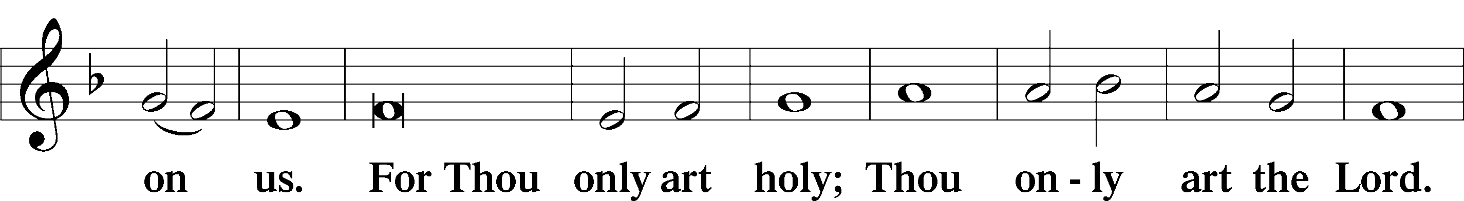
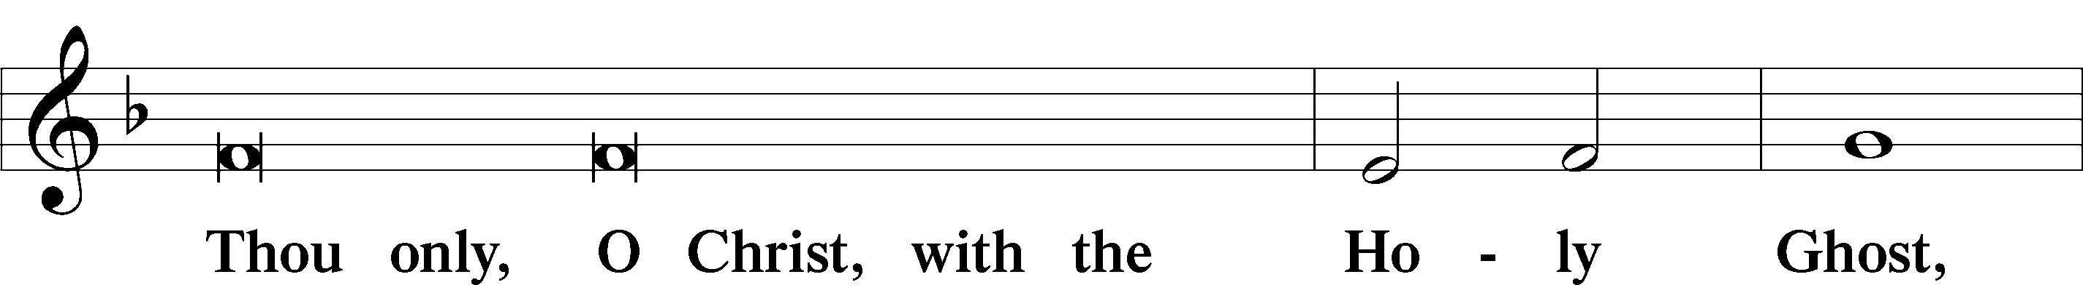
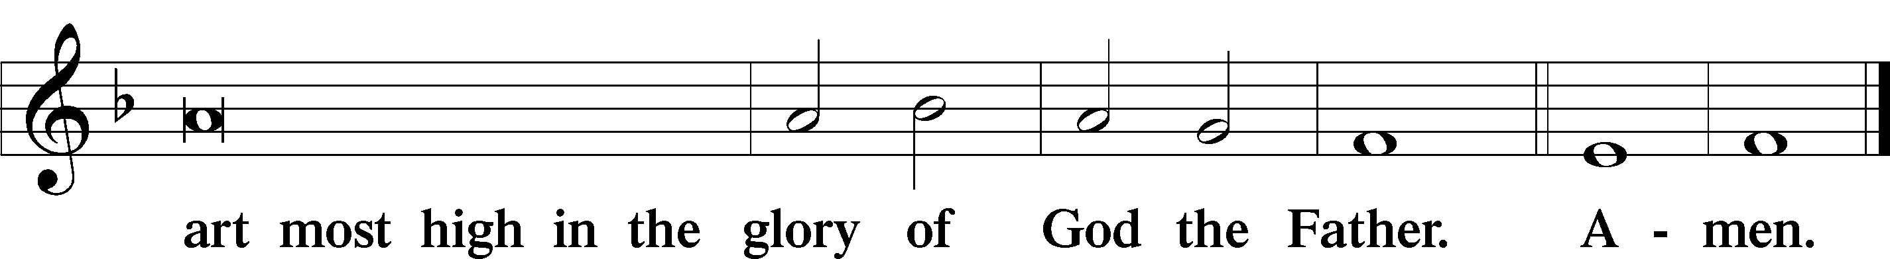

Salutation and Collect of the Day LSB 189

P The Lord be with you.
C And with thy spirit.

P Let us pray.

O Lord, mercifully hear our prayers and having set us free from the bonds of our sins deliver us from every evil; through Jesus Christ, Your Son, our Lord, who lives and reigns with You and the Holy Spirit, one God, now and forever.

C Amen.

Sit

Old Testament Reading I Samuel 16:1-13
The Old Testament reading for Sexagesima is from I Samuel, the sixteenth chapter.

The Lord said to Samuel, “How long will you grieve over Saul, since I have rejected him from being king over Israel? Fill your horn with oil, and go. I will send you to Jesse the Bethlehemite, for I have provided for myself a king among his sons.” And Samuel said, “How can I go? If Saul hears it, he will kill me.” And the Lord said, “Take a heifer with you and say, ‘I have come to sacrifice to the Lord.’ And invite Jesse to the sacrifice, and I will show you what you shall do. And you shall anoint for me him whom I declare to you.” Samuel did what the Lord commanded and came to Bethlehem. The elders of the city came to meet him trembling and said, “Do you come peaceably?” And he said, “Peaceably; I have come to sacrifice to the Lord. Consecrate yourselves, and come with me to the sacrifice.” And he consecrated Jesse and his sons and invited them to the sacrifice.
When they came, he looked on Eliab and thought, “Surely the Lord’s anointed is before him.” But the Lord said to Samuel, “Do not look on his appearance or on the height of his stature, because I have rejected him. For the Lord sees not as man sees: man looks on the outward appearance, but the Lord looks on the heart.” Then Jesse called Abinadab and made him pass before Samuel. And he said, “Neither has the Lord chosen this one.” Then Jesse made Shammah pass by. And he said, “Neither has the Lord chosen this one.” And Jesse made seven of his sons pass before Samuel. And Samuel said to Jesse, “The Lord has not chosen these.” Then Samuel said to Jesse, “Are all your sons here?” And he said, “There remains yet the youngest, but behold, he is keeping the sheep.” And Samuel said to Jesse, “Send and get him, for we will not sit down till he comes here.” And he sent and brought him in. Now he was ruddy and had beautiful eyes and was handsome. And the Lord said, “Arise, anoint him, for this is he.” Then Samuel took the horn of oil and anointed him in the midst of his brothers. And the Spirit of the Lord rushed upon David from that day forward. And Samuel rose up and went to Ramah.

P This is the Word of the Lord.
C Thanks be to God.

Gradual Psalm 77:14-15
P You are the God who works wonders;
you have made known your might among the peoples.
C You with your arm redeemed your people,
the children of Jacob and Joseph.

Epistle Reading I Corinthians 13:1-13
The Epistle Reading is from First Corinthians, the thirteenth chapter.

If I speak in the tongues of men and of angels, but have not love, I am a noisy gong or a clanging cymbal. And if I have prophetic powers, and understand all mysteries and all knowledge, and if I have all faith, so as to remove mountains, but have not love, I am nothing. If I give away all I have, and if I deliver up my body to be burned, but have not love, I gain nothing.
Love is patient and kind; love does not envy or boast; it is not arrogant or rude. It does not insist on its own way; it is not irritable or resentful; it does not rejoice at wrongdoing, but rejoices with the truth. Love bears all things, believes all things, hopes all things, endures all things.
Love never ends. As for prophecies, they will pass away; as for tongues, they will cease; as for knowledge, it will pass away. For we know in part and we prophesy in part, but when the perfect comes, the partial will pass away. When I was a child, I spoke like a child, I thought like a child, I reasoned like a child. When I became a man, I gave up childish ways. For now we see in a mirror dimly, but then face to face. Now I know in part; then I shall know fully, even as I have been fully known.
So now faith, hope, and love abide, these three; but the greatest of these is love.

P This is the Word of the Lord.
C Thanks be to God.

Stand

Alleluia LSB 190
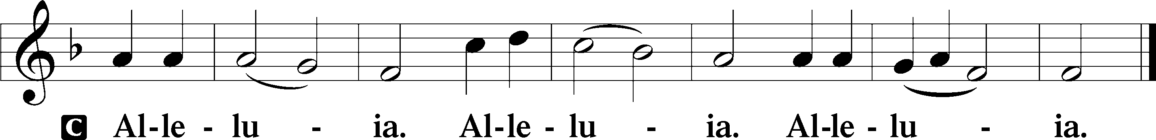

Holy Gospel Luke 18:31-43
P The Holy Gospel according to St. Luke, the eighteenth chapter.
C Glory be to Thee, O Lord.

Taking the twelve, [Jesus] said to them, “See, we are going up to Jerusalem, and everything that is written about the Son of Man by the prophets will be accomplished. For he will be delivered over to the Gentiles and will be mocked and shamefully treated and spit upon. And after flogging him, they will kill him, and on the third day he will rise.” But they understood none of these things. This saying was hidden from them, and they did not grasp what was said.
As he drew near to Jericho, a blind man was sitting by the roadside begging. And hearing a crowd going by, he inquired what this meant. They told him, “Jesus of Nazareth is passing by.” And he cried out, “Jesus, Son of David, have mercy on me!” And those who were in front rebuked him, telling him to be silent. But he cried out all the more, “Son of David, have mercy on me!” And Jesus stopped and commanded him to be brought to him. And when he came near, he asked him, “What do you want me to do for you?” He said, “Lord, let me recover my sight.” And Jesus said to him, “Recover your sight; your faith has made you well.” And immediately he recovered his sight and followed him, glorifying God. And all the people, when they saw it, gave praise to God.

P This is the Gospel of the Lord.
C Praise be to thee, O Christ.
Let us listen to these blind men, who saw better than many. They were not able to see the Lord when he came near, nor had they anyone to guide them. Nevertheless, they strove to approach, crying out in a loud voice, and when reproved for this cried out all the more. For such is the nature of a persevering soul – it is borne up by the very things that hinder it.

St. John Chrysostom
(349-407 AD)

Nicene Creed
C I believe in one God,
the Father Almighty,
maker of heaven and earth
and of all things visible and invisible.
And in one Lord Jesus Christ,
the only-begotten Son of God,
begotten of His Father before all worlds,
God of God, Light of Light,
very God of very God,
begotten, not made,
being of one substance with the Father,
by whom all things were made;
who for us men and for our salvation came down from heaven
and was incarnate by the Holy Spirit of the virgin Mary
and was made man;
and was crucified also for us under Pontius Pilate.
He suffered and was buried.
And the third day He rose again according to the Scriptures
and ascended into heaven
and sits at the right hand of the Father.
And He will come again with glory to judge both the living and the dead,
whose kingdom will have no end.

And I believe in the Holy Spirit,
the Lord and giver of life,
who proceeds from the Father and the Son,
who with the Father and the Son together is worshiped and glorified,
who spoke by the prophets.
And I believe in one holy Christian and apostolic Church,
I acknowledge one Baptism for the remission of sins,
and I look for the resurrection of the dead
and the life T of the world to come. Amen.

Sit

Hymn of the Day Praise the One Who Breaks the Darkness LSB 849

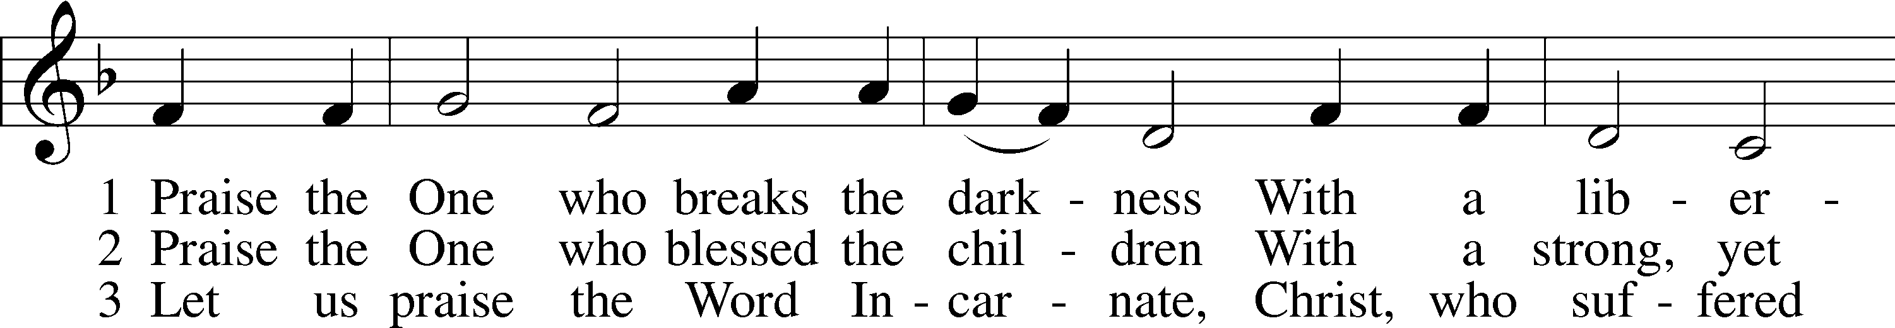
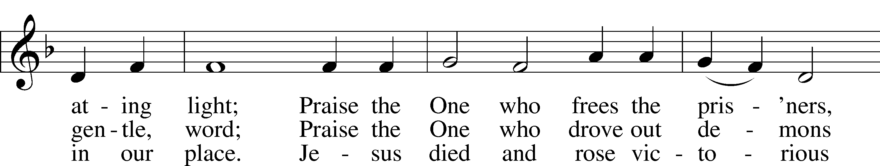
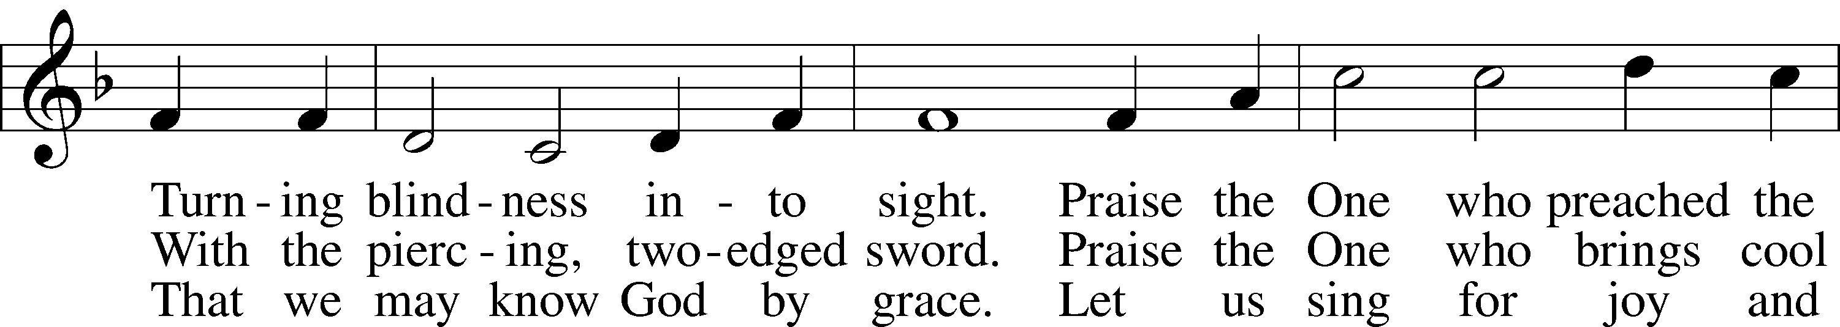
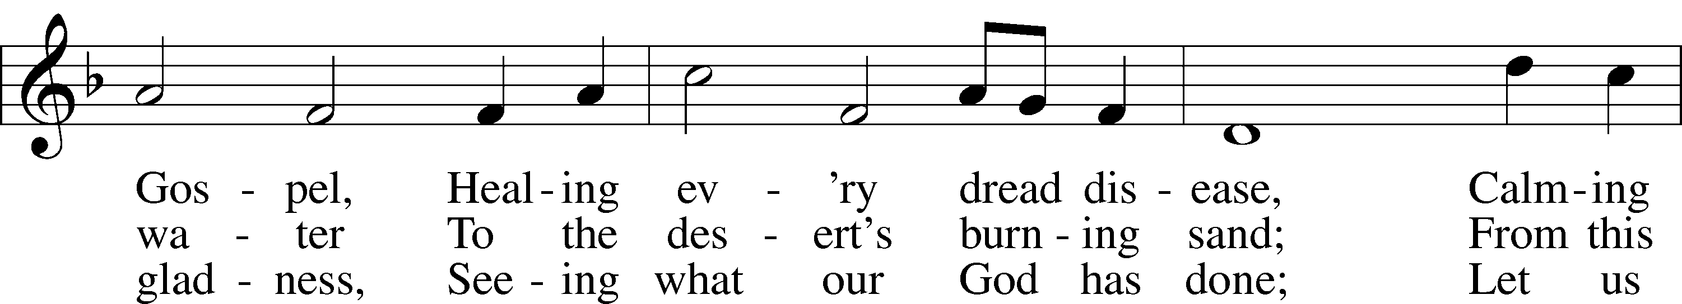
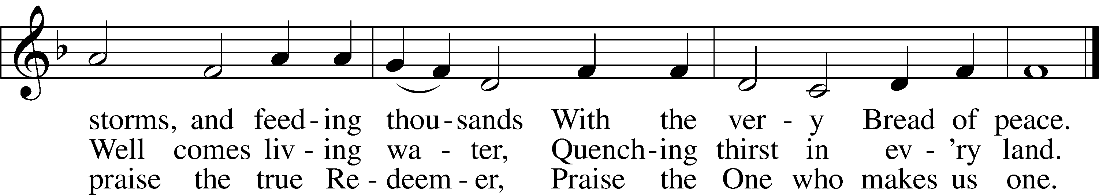
Tune: Public domain
Text: © 1987 Hope Publishing Co. Used by permission: LSB Hymn License no. 110000259

Sermon Knowledge, Assent, and Trust Luke 18:31-43

Offertory
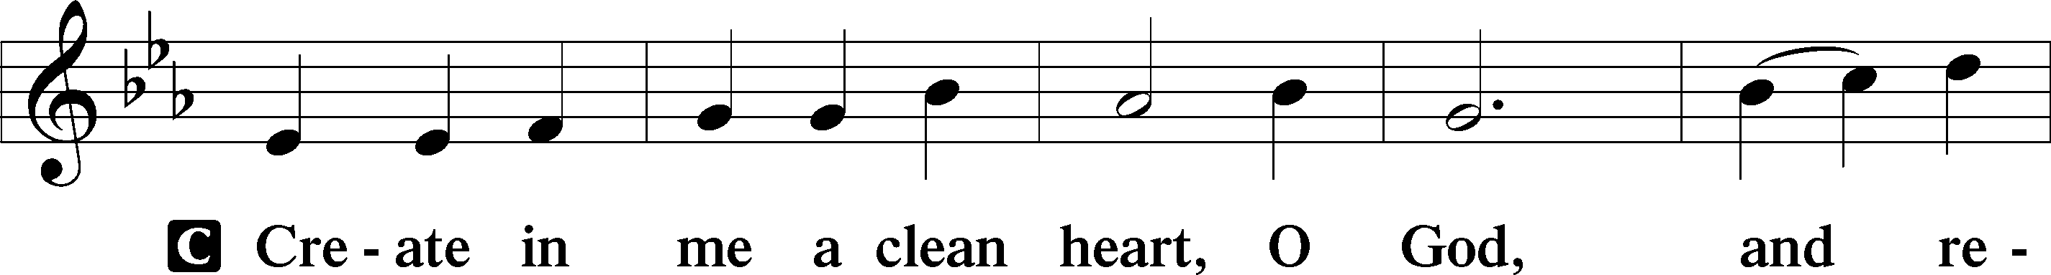
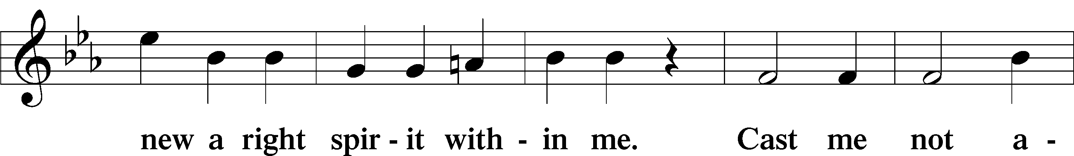
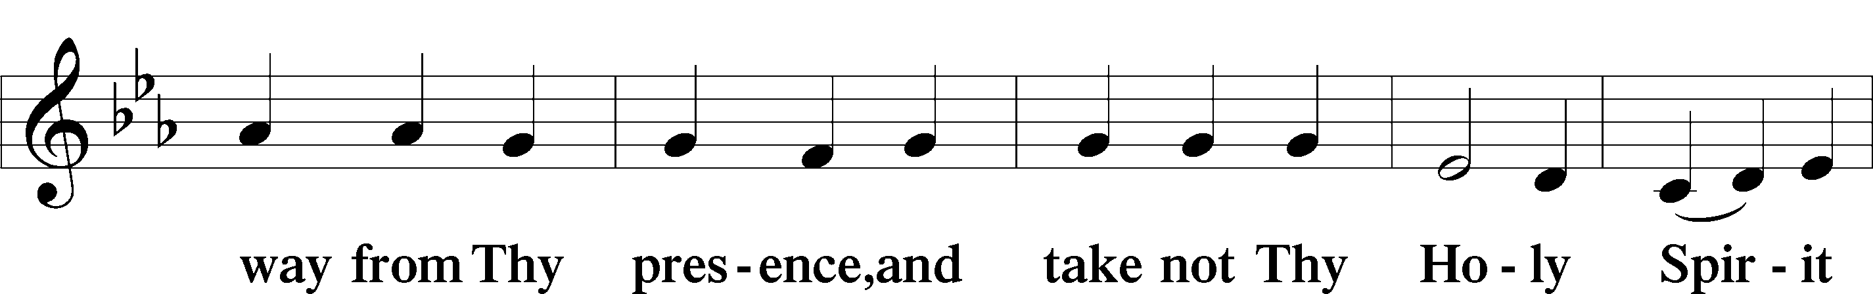
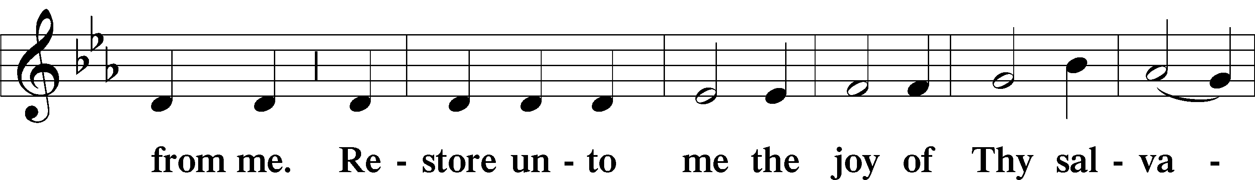
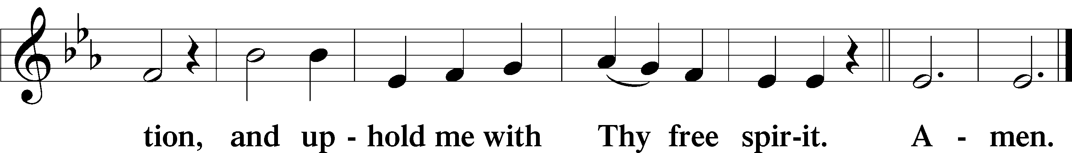

Prayer of the Church

P Lord in Your Mercy,
C Hear our Prayer
Service of the Sacrament
Preface LSB 194

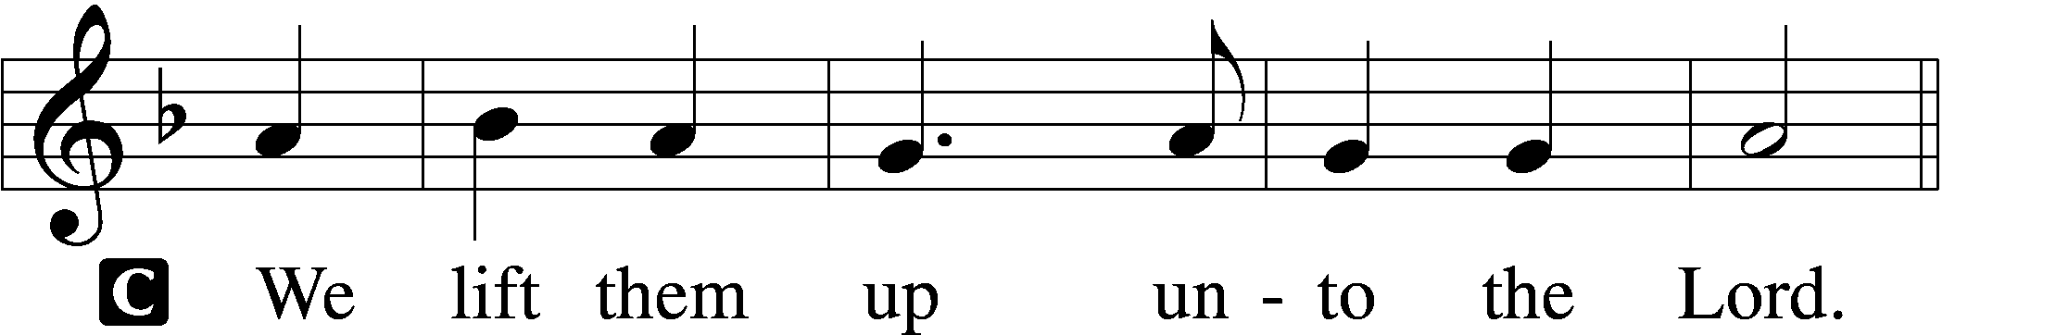

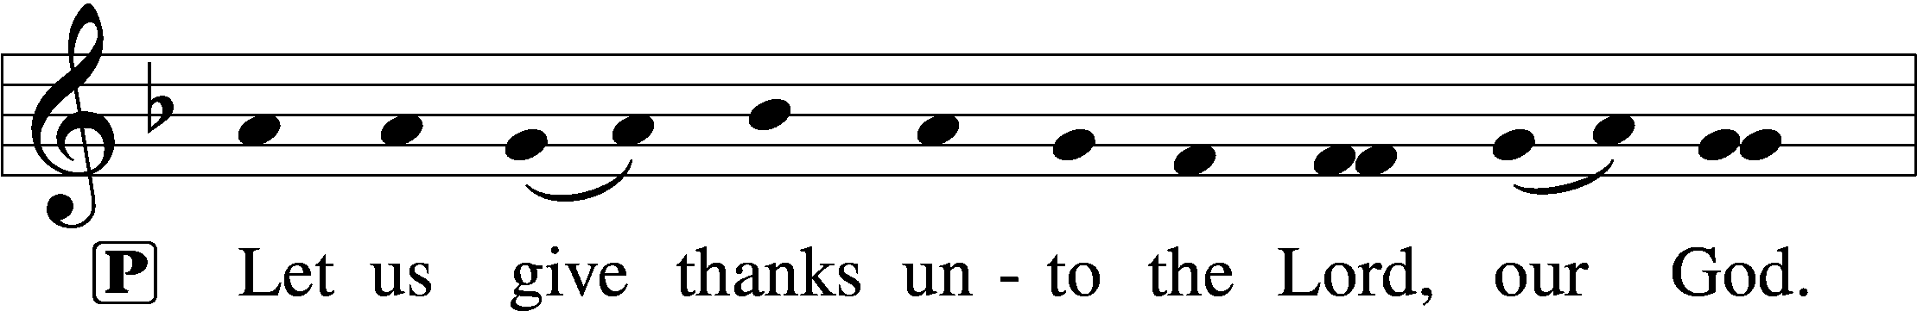
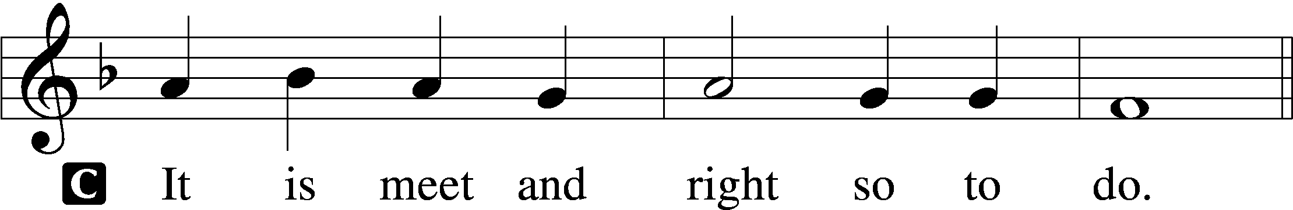

Proper Preface

P It is truly meet, right, and salutary that we should at all times and in all places give thanks to You, holy Lord, almighty Father, everlasting God, through Jesus Christ, our Lord. […] Therefore with angels and archangels and with all the company of heaven we laud and magnify Your glorious name, evermore praising You and saying:
Sanctus LSB 195
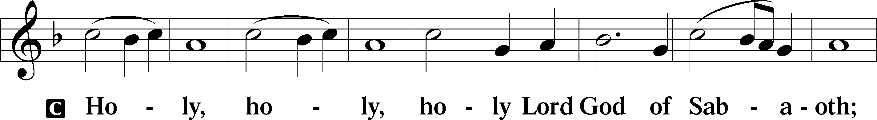
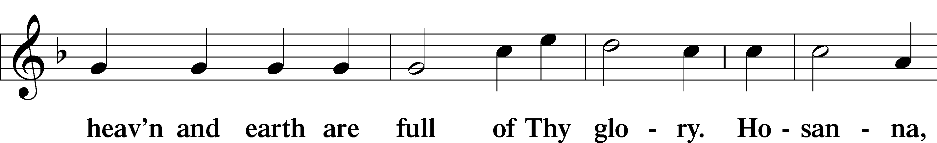
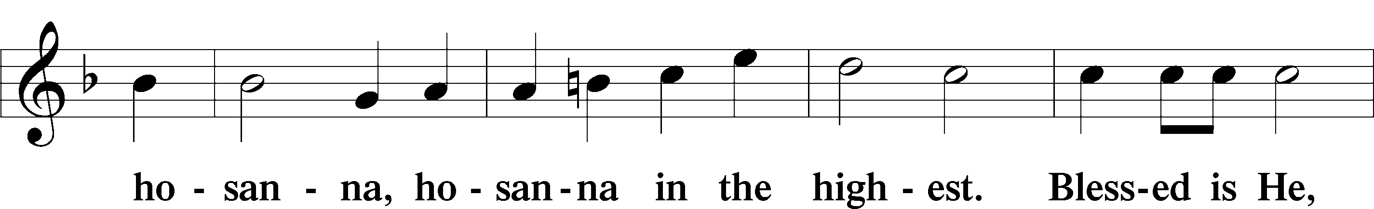
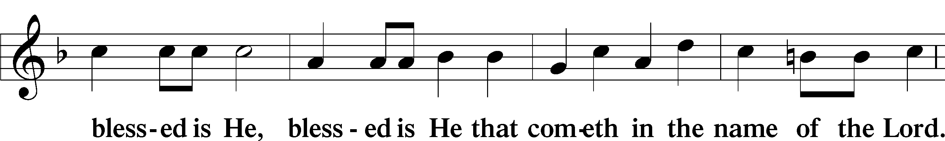
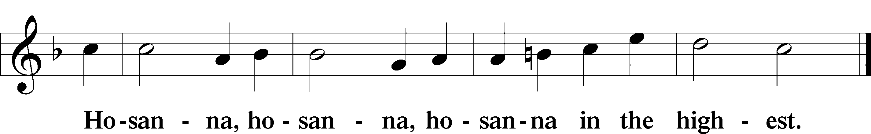

Lord’s Prayer Matthew 6:9-13
P Lord, remember us in Your kingdom and teach us to pray:
C Our Father who art in heaven,
God hath most graciously prepared a great supper, but those who would enjoy it must come with hearts hungering and thirsting after righteousness.
He who tastes not, perceives not the sweetness of this heavenly feast; and he who does not hunger for it, does not taste it. To believe in Christ is to come to this heavenly banquet. But no one can believe in Christ who does not acknowledge his sins in true contrition and penitence. Contrition is the spiritual hunger of our souls; and by faith our souls are spiritually fed.
Johann Gerhard, Sacred
Meditations, “Meditation XVI”

hallowed be Thy name,

Thy kingdom come,
Thy will be done on earth
as it is in heaven;
give us this day our daily bread;
and forgive us our trespasses
as we forgive those
who trespass against us;
and lead us not into temptation,
but deliver us from evil.
For Thine is the kingdom
and the power and the glory
forever and ever. Amen.

Words of Our Lord
P Our Lord Jesus Christ, on the night when He was betrayed, took bread, and when He had given thanks, He broke it and gave it to the disciples and said: “Take, eat; this is My body, which is given for you. This do in remembrance of Me.” In the same way also He took the cup after supper, and when He had given thanks, He gave it to them saying: “Drink of it, all of you; this cup is the new testament in My blood, which is shed for you for the forgiveness of sins. This do, as often as you drink it, in remembrance of Me.

Pax Domini LSB 197

P The peace of the Lord be with you always.
C Amen.

Agnus Dei LSB 198

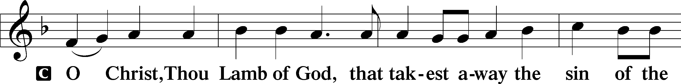
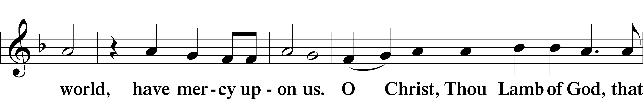
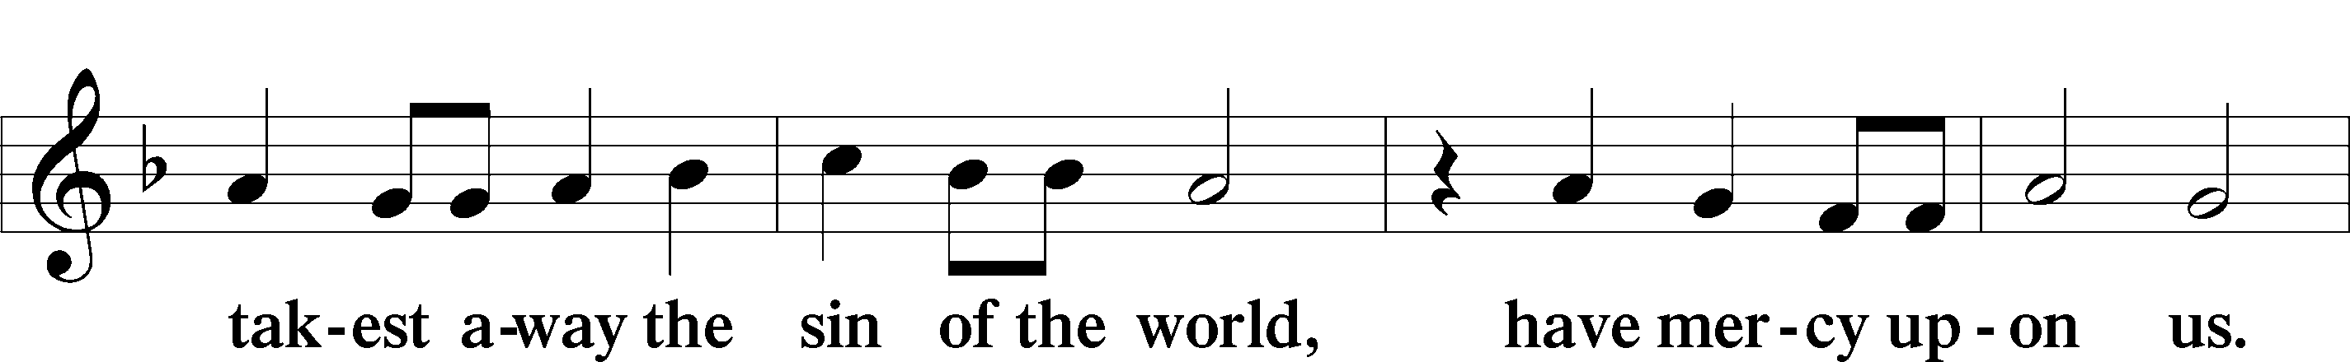
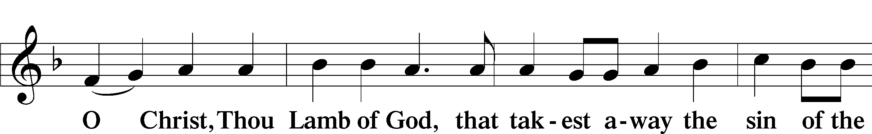
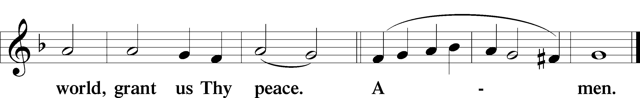

Distribution
We at Zion Lutheran Church of Augsburg believe and confess along with the Holy Scriptures, that this bread and wine in the Sacrament of Holy Communion are truly the body and blood of our Lord Jesus Christ, instituted by Christ Himself, for us Christians to eat and drink. The gifts of His physical body and blood are given in, with, and under the elements of bread and wine at the altar. Those who are communicant members of a Lutheran Church—Missouri Synod congregation are welcome to commune at this altar with us. Other guests wishing to join our confession and receive this Holy Sacrament are invited to meet with the Pastor for Catechesis before communing. Anyone not communing may still come forward, crossing their arms at the rail, to receive a blessing from the Pastor.

Communion Hymn Lord, Keep Us Steadfast in Your Word LSB 655

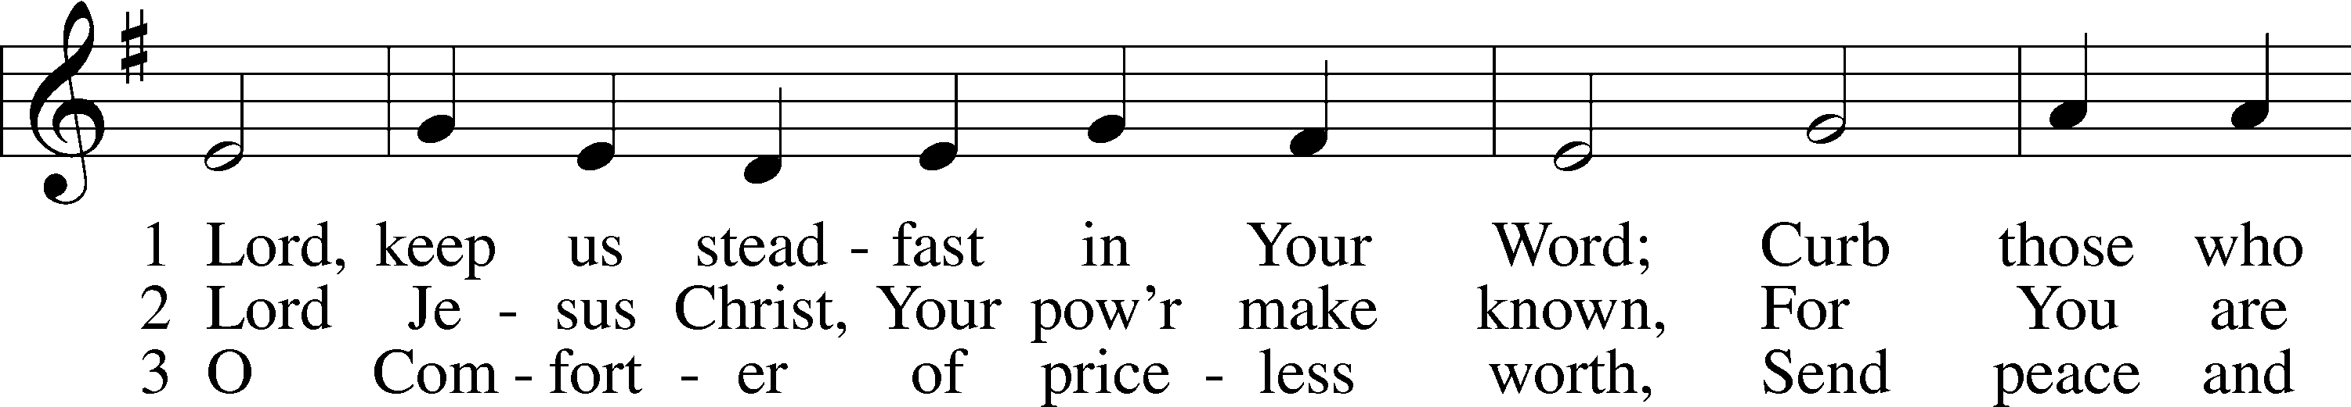
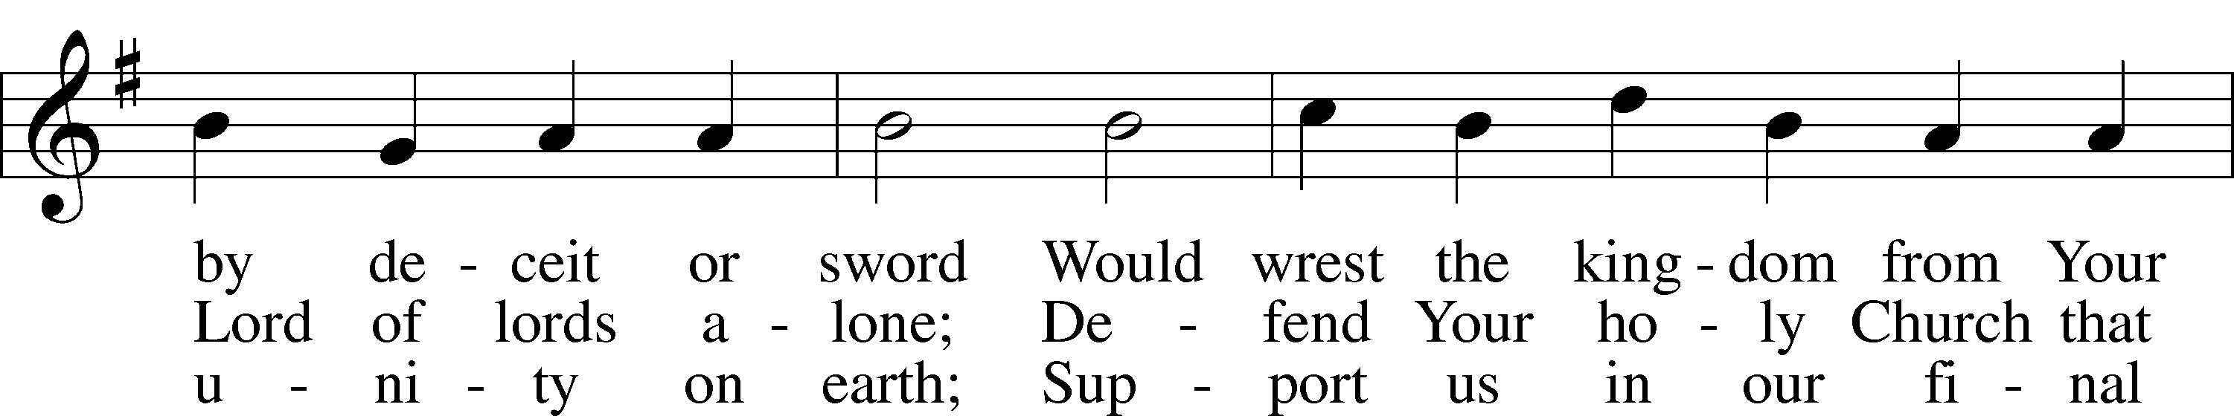
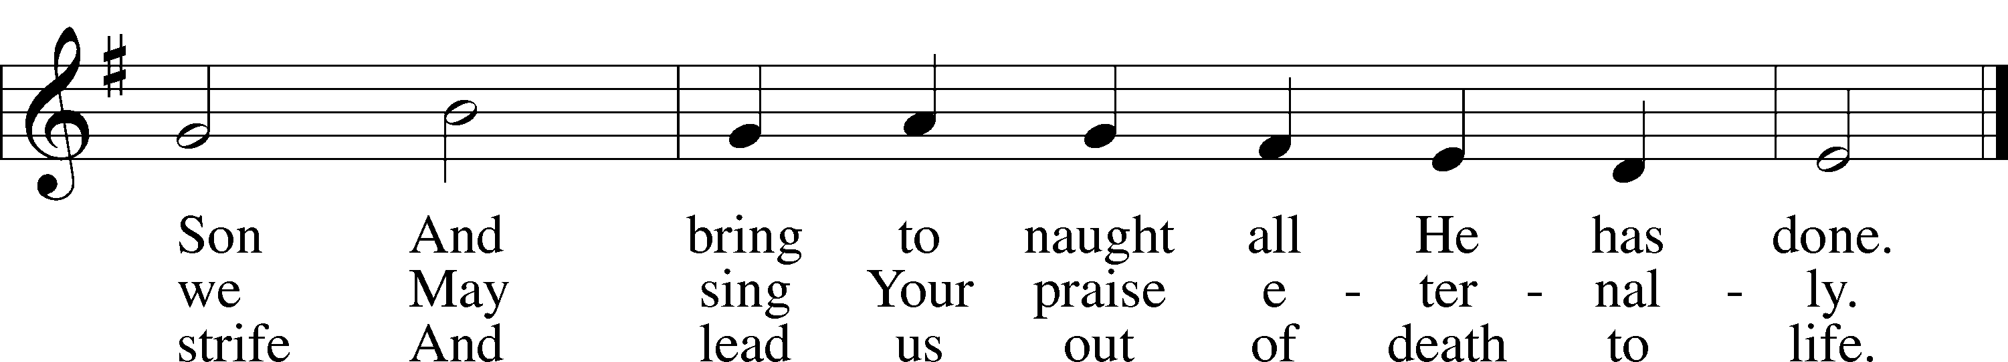
Text and tune: Public domain

Nunc Dimittis LSB 199
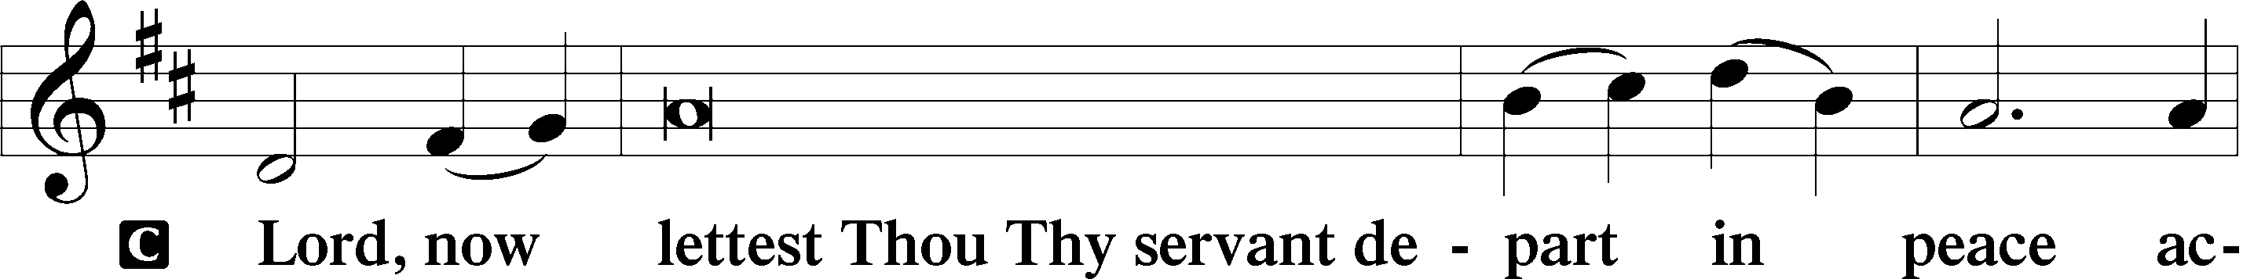
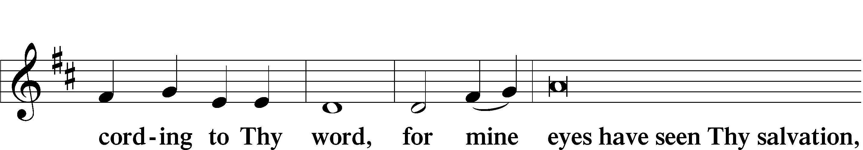
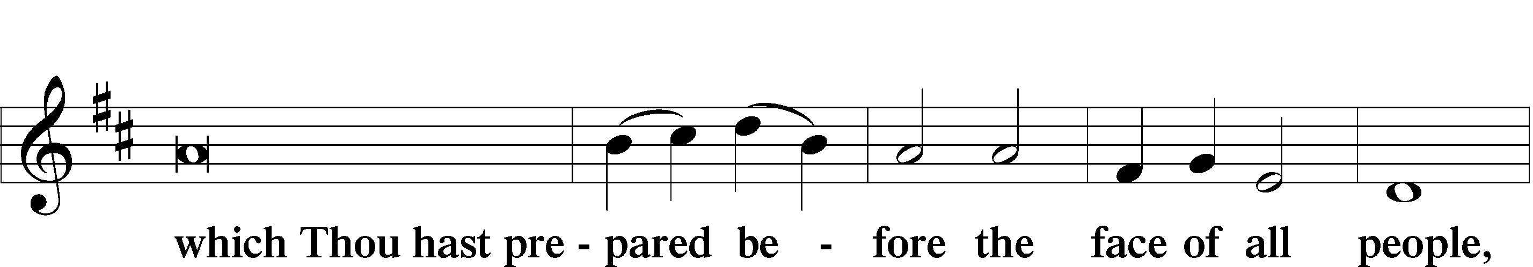
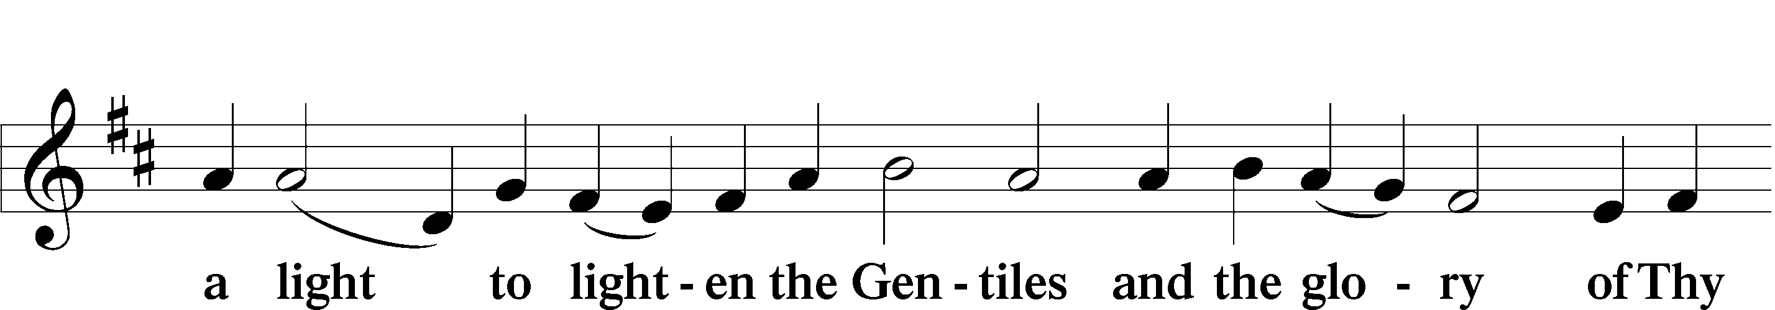
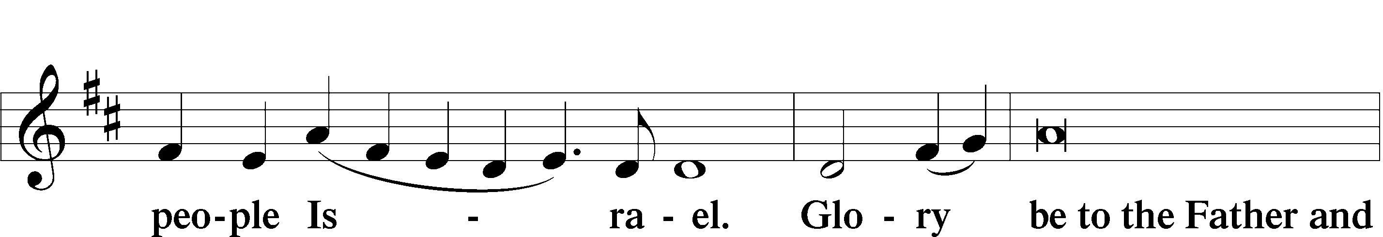
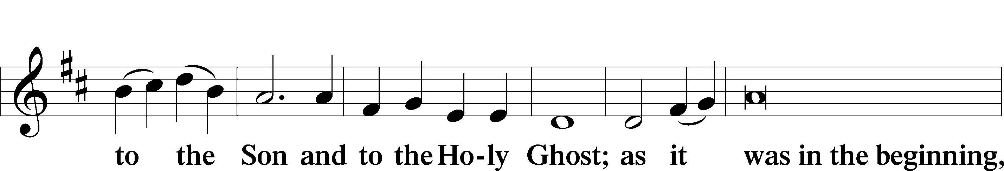
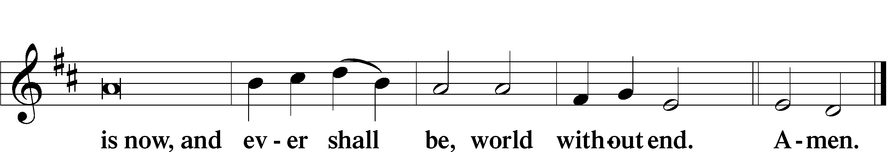
Thanksgiving LSB 200

P Oh give thanks unto the Lord, for He is good.

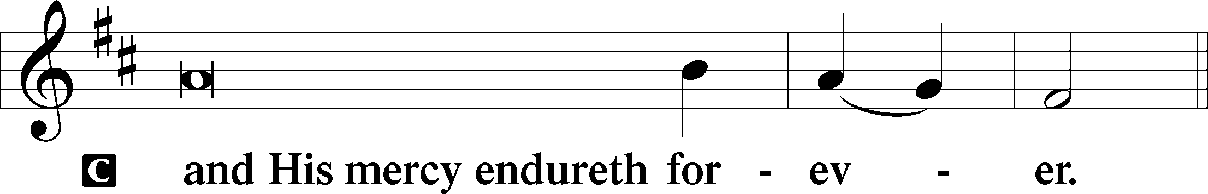

Post-Communion Collect LSB 201
P Let us pray. […]

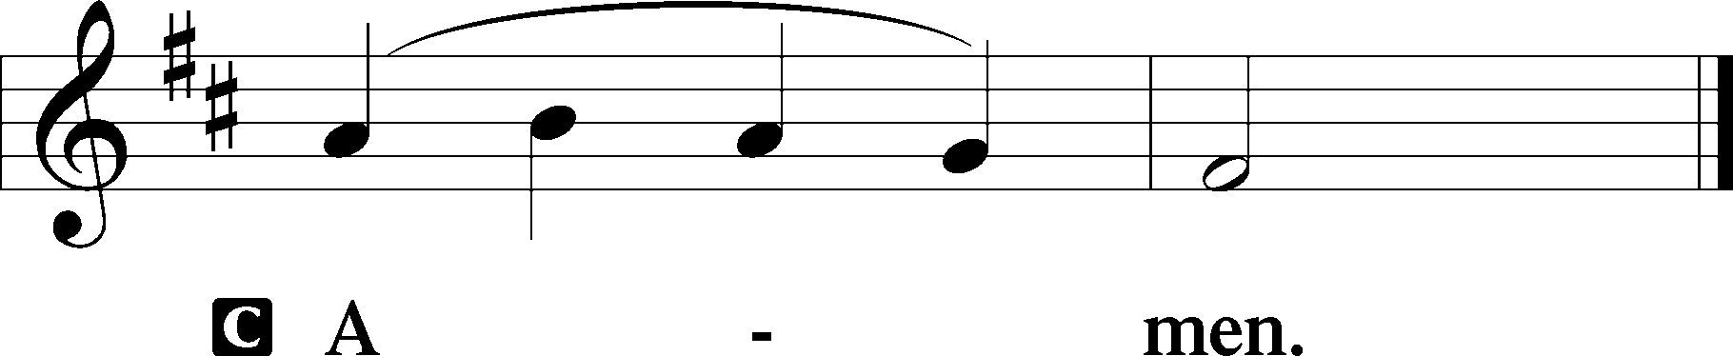

Salutation, Benedicamus, and Benediction

P The Lord be with you.

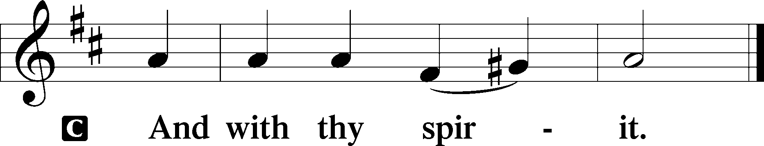

P Bless we the Lord.

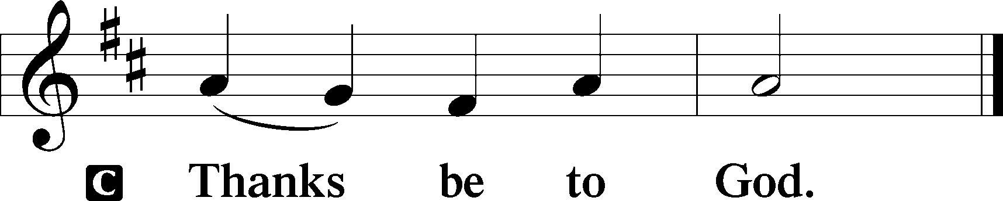

P The Lord bless you and keep you,
The Lord makes His face shine upon you and be gracious unto you
The Lord lift up His countenance upon you and T give you peace.

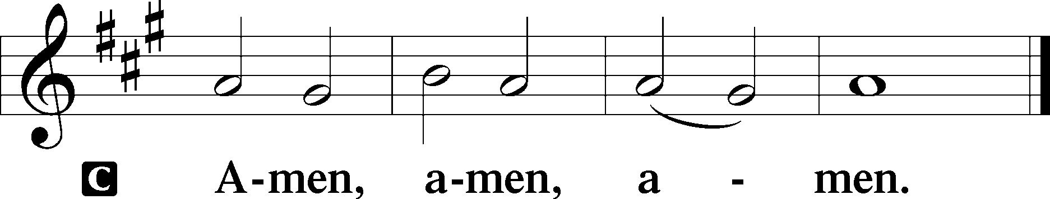

Sit

Recessional Hymn Lord, ‘Tis Not That I Did Choose Thee LSB 573

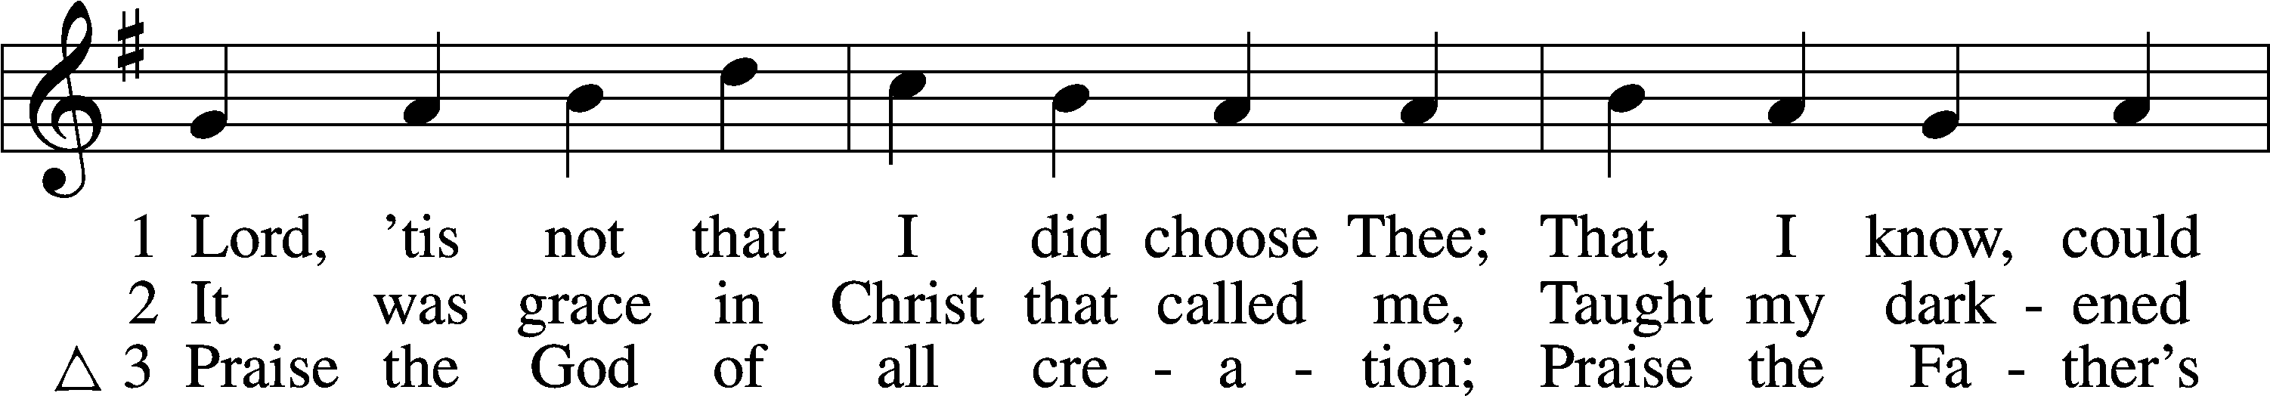
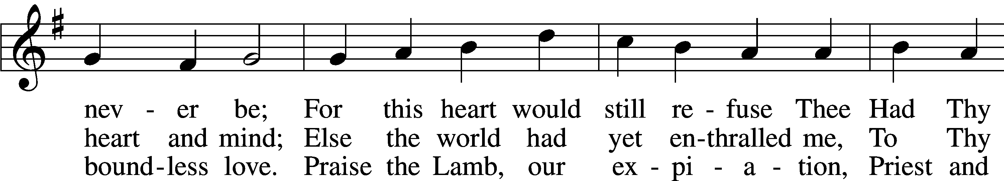
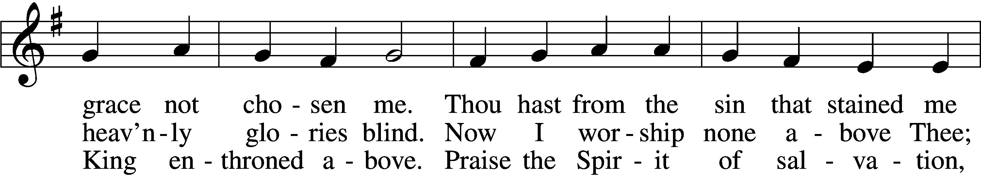
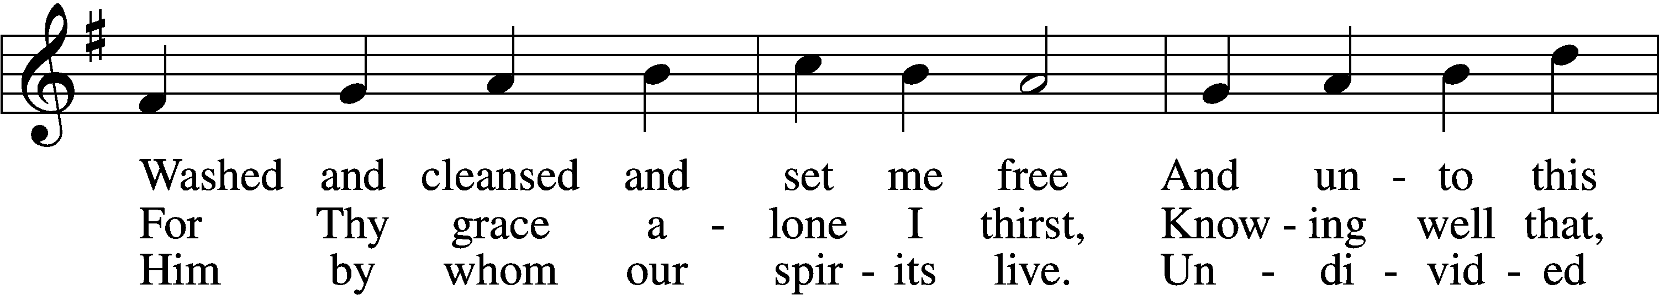
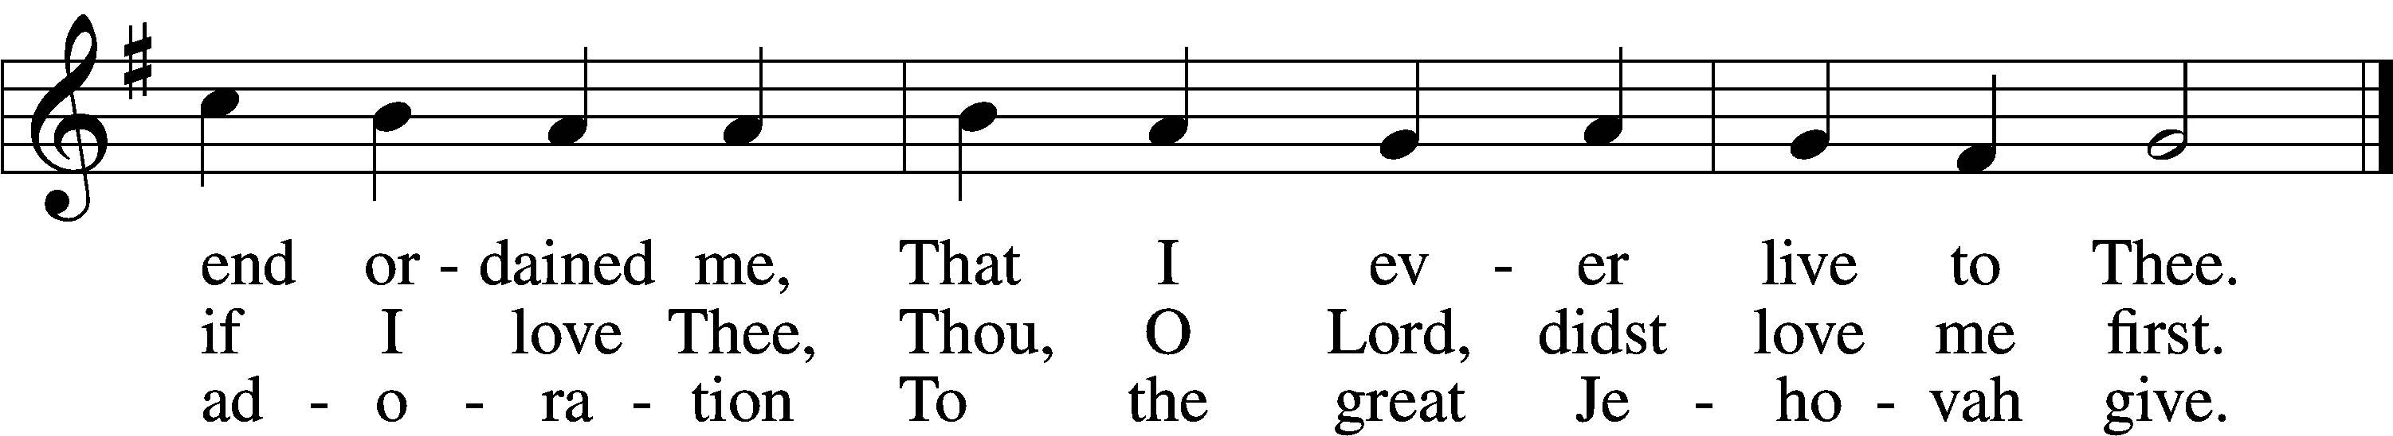
Text and tune: Public domain

The Prayers of the Church

Persecuted Christians in:
Sri Lanka
Colombia
Bangladesh
Palestinian Territories
Azerbaijan

Partner Church
Evangelical Lutheran Church of Ghana

Comfort, Health, and Recovery
Amy Villalobos (sister-in-law of Katie)
Glenda Schrock
Bob Allen
Susan Allen
David Knoerschild
Peggy Flatt (friend of Susan Colles)
Angela Jones (friend of Phyllis Campbell)
Elizabeth Sharp (friend of Phyllis Campbell)
Janice Conley (friend of Delores McDaniel)
Bo Rowe
Barbara Smith
Astasha Lamar
John Kuretsch
Joe Fabry (relative of Dave Boswell)
Mary Standridge(friend of Delores McDaniel)
Edmond Drittler (friend of Delores McDaniel)
Joyce Mendenhall (friend of Susan Colles)

Homebound
Dorothy Birkhahn
Betty Bocksnick
Nettie Grant
Gwen Hale
Tom Harms
Kenneth Hottinger Sr.
Helen Rick
Glenda Schrock
Lawrence Steuber

Catechumens
Emmett Schlittenhart
Gavin Rion
Tatum Rion
Alison Waldo
Alivia Waldo
Chance Paylor

Serving in the armed forces
Logan Kremers
Matthew Allen
Brian Rutledge
Trent Hale
Josh Imme
Dale Ozment

Dave Sheely (brother of Linda Shott)

When hospitalized, sick, needing prayer or absolution,
contact Pastor Ralston anytime at 501-454-0581.

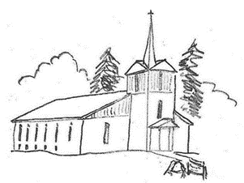

ZION

Offering
If you are not able to attend church, we encourage you to still send in offerings. During this time, it’s important to remember that we are borrowers, not owners, of everything we have. The Lord generously gives us means to support us in this life. Yet, he also expects “tithes and contributions” (Malachi 3:8) to be made to Him. By so doing, you are spiritual discipling yourself, demonstrating where your heart’s treasures are. Jesus says, “where your treasure is, there your heart will be also… No one can serve God and money.” (Matthew 6:21, 24).

Offerings can be made to the following PO Box address:

Zion Lutheran Church
PO Box 327
Dover, AR 72837

Pick-up pre-stamped envelopes in the Narthex.

Every Member Visitation
Since COVID started, Pastor has not been able to complete his visits to the home of every congregation member. If you like to go ahead and have your visit with pastor, please sign up on the sheet in the back with your name, date, and time. Pastor will call to confirm with you.

The Fruits of Our Faith
2/07/2021
Worship Attendance: 57
Adult Sunday School: 7
Children’s Sunday School: 8

General Fund: $ 4,035
Food Pantry: $ 636

Lenten Midweek
Ash Wednesday begins on February 17th. Following Ash Wednesday, our midweek Lenten series is over the book of Romans, titled, “Christ our Priest Today, Yesterday, and Forever.” Lenten midweek services begin February 24th.

Easter Lilies
It is time to start putting in orders for Easter Lilies! Flowers are $8 each. Orders need to be put in before March 1st. There is a sign-up sheet in the back. Please help us adorn the chancel in celebration of the Risen Christ or in memory of loved ones!
Quinquagesima
February 14, 2021
Zion
Lutheran Church
93 Augsburg Rd
London, AR 72847
PO Box 327
Dover, AR 72837
479-331-3277

The Reverend Joshua Ralston
Pastor
Rusty Dorn
Congregational President
Jeff Schlittenhart
Head Elder
Diane Ragsdale
LWML President
Nikki Dorn
Treasurer
Phyllis Campbell
Office Assistant
Email: rev.jralston@gmail.com
Website: zionaugsburg.org
Facebook: facebook.com/ AugsburgZionLutheranChurch

If calling for a Pastoral Emergency, contact Pastor Ralston directly:
Cell…………...……..501-454-0581
Church……..........479-331-3277

Restrooms
Restrooms are located in the Narthex outside of the Sanctuary and in the basement Fellowship Hall. Please see an usher if you need assistance.
Nursery
The Nursery is located in the Narthex outside of the Sanctuary.
Congregational Membership
New members are received by Baptism, Confirmation, Transfer, or Profession of Faith (after receiving Pastoral instruction). Please speak with Pastor Ralston for more details.
Pastoral Consultation
Pastoral Consultation based on the Holy Scriptures is available from the Pastor. Please speak with Pastor Ralston to make an appointment.
Sick and Homebound
The sick and homebound are visited regularly by the Pastor with the Scriptures and Sacrament. Please contact Pastor Ralston if you know of any parishioner in need of pastoral visitation.
Pastor’s Bible Study, Teen, and Children’s Sunday School
Sunday School begins at 10:15 am. Anyone from confirmation age on up is welcome to attend Bible Study. Teen and Children’s Sunday School is held every Sunday in the basement Fellowship Hall/Family Center (Ages 0 and up).
Listen to Lutheran Radio
Listen: Issues, Etc. is talk-radio for the thinking Christian. Listen 24/7 at www.IssuesETC.org The Lutheran Hour is broadcast on KARV 610 AM/101.3 FM every Sunday at 7:30AM.

