The Divine Service

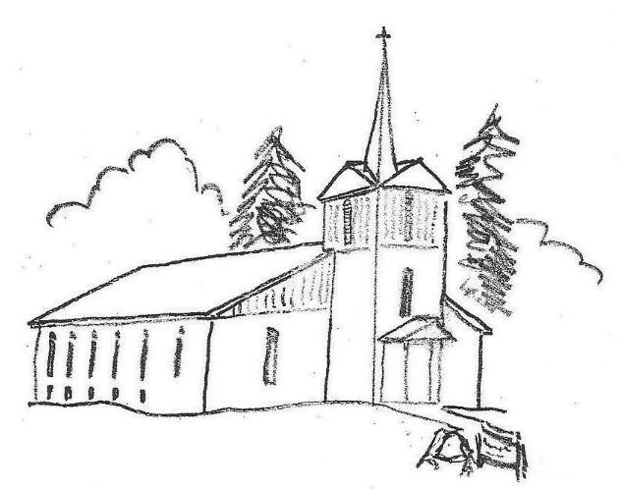

Eleventh Sunday after Trinity

***Divine Service, Setting Three***

Zion Lutheran

Church

_________________

Welcome

**Help the Needy**

*God is the God of the humble, the miserable, the afflicted, the oppressed, the desperate, and of those who have been brought down to nothing at all. And it is the nature of God to exalt the humble, to feed the hungry, to enlighten the blind, to comfort the miserable and afflicted, to justify sinners, to give life to the dead, and to save those who are desperate and damned.*

**Martin Luther**, “Lectures on Galatians,” AE 26:314

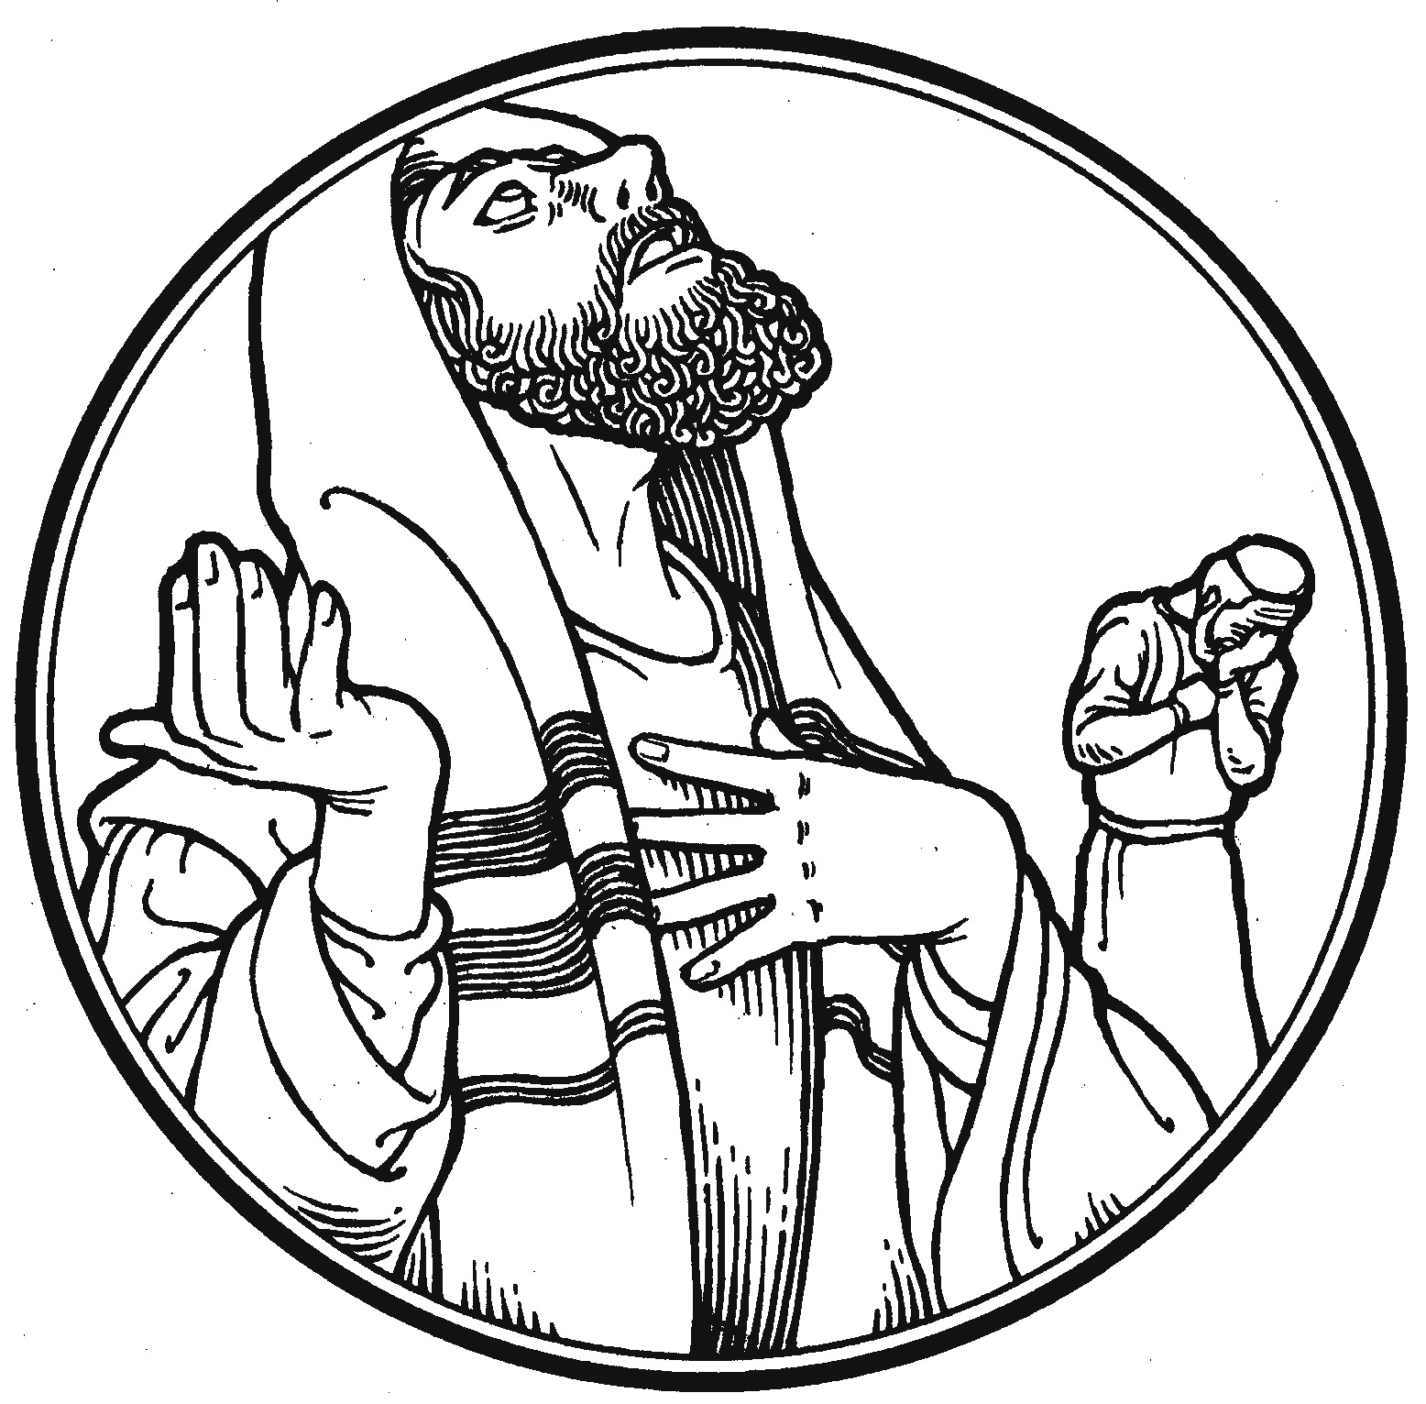

September 1, 2019 T 10:30 A.M.

**Welcome to today’s Divine Service**

We are very happy that you are here today!

At Zion, the bulletin and Lutheran Service Book (LSB) are both used to lead us through our worship. To help guide you during the service, below are some helpful tips.

* The Divine Service liturgy setting for today’s service is shown on the front and Page 3 of the bulletin.
* For each section of the Divine Service, the page number in the hymnal is listed in the bulletin on the right side of the page, i.e., *LSB 184,* which is found towards the front of the hymnal. All responses are sung unless they are printed in the bulletin.
* The Introit, Collect, Gradual, all Scripture readings, and prayers for a given Sunday are printed in the bulletin along with any spoken responses. On Communion Sundays, the Proper Preface will also be printed.
* P indicates sections spoken by the Pastor. C indicates responses by the Congregation and will be in **bold print.**
* All hymns are listed in the bulletin with the name of the hymn and page number, i.e., ***Thy Strong Word LSB 578.***  They are also shown on the Hymn board at the front of the church.
* The ***red text*** in both the bulletin and the hymnal shows when the congregation should stand or sit during the Divine Service. The Pastor may also provide direction.

**A Special Welcome to Those with Young Children**

At Zion we want families with children to feel at home.

* First, please relax and enjoy your time here. Jesus knows that children tend to wiggle and squawk a bit, so please don’t feel embarrassed by it. Your children are welcome at Zion.
  + To make it a bit easier on your family, please dare to sit toward the front where your children can easily see the front of the Church, note the colors, hear the bells, smell the candles, watch the pastor, wonder about the stained-glass windows above the altar and embrace the action at the altar. What Jesus does here promises to engage them.
  + As we go, softly explain the Liturgy to your children, encouraging them to chime in on their parts: Amen! Lord have mercy! And with thy Spirit! I believe! Our Father! All of that belongs to them too.
  + Be sure to sing and say and pray your parts too as you stand and sit. Your children learn by following your lead.
  + If you and your child must leave, please hurry back. We want you and your children here very much.
  + If you need a little help, just ask. There are lots of folks here who will lend you a hand.

Please know that while you are caring for your children, the rest of us will be rejoicing in Jesus’ words, “Let the little children come to me and do not hinder them, for the kingdom of God belongs to such as these” (Luke 18:16).

We know that your children are a gift to the Church, so we will do our best to welcome, smile, encourage, help and bless you all. Welcome to Zion!



***Divine Service, Setting Three***

# The Preparation

Processional Hymn Just As I Am Without One Plea LSB 570

Stand

Invocation

The sign of the cross may be made by all in remembrance of their Baptism.

Confession of Sins and Absolution LSB 184

# Service of the Word

Introit *Psalm 68:1,3,7a,10b,19; antiphon:vv.5b, 6a, 35b*

P God is in his holy habitation;  
 [he] settles the solitary in a home.  
**C**  **The God of Israel—he is the one  
 who gives power and strength to his people.**P God shall arise, his enemies shall be scattered;  
 and those who hate him shall flee before him!  
**C**  **But the righteous shall be glad; they shall exult before God;  
 they shall be jubilant with joy!**P O God, when you went out before your people,  
 in your goodness, O God, you provided for the needy.  
**C** **Blessèd be the Lord, who daily bears us up;  
 God is our salvation.  
 Glory be to the Father and to the Son**  
 **and to the Holy Spirit;**  
 **as it was in the beginning,**  
 **is now, and will be forever. Amen.**  
P God is in his holy habitation;  
 [he] settles the solitary in a home.  
**C** **The God of Israel—he is the one  
 who gives power and strength to his people.**

**Kyrie** LSB 186

**Gloria in Excelsis** LSB 187

Salutation and Collect of the Day LSB 189

P Let us pray.

Almighty and everlasting God, always more ready to hear than we to pray and to give more than we either desire or deserve, pour down upon us the abundance of Your mercy, forgiving those things of which our conscience is afraid and giving us those good things that we are not worthy to ask, except through the merits and mediation of Christ, our Lord, who lives and reigns with You and the Holy Spirit, one God, now and forever.

Sit

Old Testament Reading *Genesis 4:1-15*

The Old Testament reading for the Eleventh Sunday after Trinity is from Genesis, the fourth chapter.

Now Adam knew Eve his wife, and she conceived and bore Cain, saying, “I have gotten a man with the help of the Lord.” And again, she bore his brother Abel. Now Abel was a keeper of sheep, and Cain a worker of the ground. In the course of time Cain brought to the Lord an offering of the fruit of the ground, and Abel also brought of the firstborn of his flock and of their fat portions. And the Lord had regard for Abel and his offering, but for Cain and his offering he had no regard. So Cain was very angry, and his face fell. The Lord said to Cain, “Why are you angry, and why has your face fallen? If you do well, will you not be accepted? And if you do not do well, sin is crouching at the door. Its desire is for you, but you must rule over it.”

Cain spoke to Abel his brother. And when they were in the field, Cain rose up against his brother Abel and killed him. Then the Lord said to Cain, “Where is Abel your brother?” He said, “I do not know; am I my brother’s keeper?” And the Lord said, “What have you done? The voice of your brother’s blood is crying to me from the ground. And now you are cursed from the ground, which has opened its mouth to receive your brother’s blood from your hand. When you work the ground, it shall no longer yield to you its strength. You shall be a fugitive and a wanderer on the earth.” Cain said to the Lord, “My punishment is greater than I can bear. Behold, you have driven me today away from the ground, and from your face I shall be hidden. I shall be a fugitive and a wanderer on the earth, and whoever finds me will kill me.” Then the Lord said to him, “Not so! If anyone kills Cain, vengeance shall be taken on him sevenfold.” And the Lord put a mark on Cain, lest any who found him should attack him.

P This is the Word of the Lord.

C **Thanks be to God.**

**Gradual** *Psalm 28:7b, 1a, 2a*

PIn [God] my heart trusts, and I am helped;  
 my heart exults, and with my song I give thanks to him.  
 **C** **To you, O Lord, I call; my rock, be not deaf to me,  
 hear the voice of my pleas for mercy, when I cry to you for help.**

 Epistle *I Corinthians 15:1-10*

The Epistle reading is from First Corinthians, the fifteenth chapter.

1Now I would remind you, brothers, of the gospel I preached to you, which you received, in which you stand, 2and by which you are being saved, if you hold fast to the word I preached to you—unless you believed in vain.

3For I delivered to you as of first importance what I also received: that Christ died for our sins in accordance with the Scriptures, 4that he was buried, that he was raised on the third day in accordance with the Scriptures, 5and that he appeared to Cephas, then to the twelve. 6Then he appeared to more than five hundred brothers at one time, most of whom are still alive, though some have fallen asleep. 7Then he appeared to James, then to all the apostles. 8Last of all, as to one untimely born, he appeared also to me. 9For I am the least of the apostles, unworthy to be called an apostle, because I persecuted the church of God. 10But by the grace of God I am what I am, and his grace toward me was not in vain. On the contrary, I worked harder than any of them, though it was not I, but the grace of God that is with me.

P This is the Word of the Lord.

C **Thanks be to God.**

Stand

Triple Alleluia *LSB 190*

Holy Gospel *Luke 18:9-14 LSB 190*

P The Holy Gospel according to St. Luke, the sixteenth chapter.

[Jesus] also told this parable to some who trusted in themselves that they were righteous, and treated others with contempt: “Two men went up into the temple to pray, one a Pharisee and the other a tax collector. The Pharisee, standing by himself, prayed thus: ‘God, I thank you that I am not like other men, extortioners, unjust, adulterers, or even like this tax collector. I fast twice a week; I give tithes of all that I get.’ But the tax collector, standing far off, would not even lift up his eyes to heaven, but beat his breast, saying, ‘God, be merciful to me, a sinner!’ I tell you, this man went down to his house justified, rather than the other. For everyone who exalts himself will be humbled, but the one who humbles himself will be exalted.”

Apostles’ Creed LSB 192

Sit

Children’s Message

Hymn of the Day Oh How Great Is Your Compassion LSB 559

Sermon “A Harsh Blow to Pride” Luke 18:9-14

Stand

Offertory LSB 192

Sit

Offering

Stand

Jesus is the God whom we can approach

without pride and before whom we can

humble ourselves without despair.

-Blaise Pascal, *Pensées*, p. 69

Prayer of the Church

P Let us pray to the Lord,

C Lord have mercy.

Lord’s Prayer LSB 196

Sending Prayer

P Almighty God, grant to Your Church Your Holy Spirit and the wisdom that comes down from above, that Your Word may not be bound but have free course and be preached to the joy and edifying of Christ’s holy people, that in steadfast faith we may serve You and, in the confession of Your name, abide unto the end; through Jesus Christ, our Lord.

C Amen

Benediction LSB 202

Sit

Recessional Hymn When in the Hour of Deepest Need LSB 615

Life Together

Pray As You Go

*The Lord has exalted me by a gift so great, so unheard of, that language is useless to describe it; and the depths of love in my heart can scarcely grasp it. I offer then all the powers of my soul in praise and thanksgiving. As I contemplate his greatness, which knows no limits, I joyfully surrender my whole life, my senses, my judgment, for my spirit rejoices in the eternal Godhead of the Jesus, that Saviour, whom I have conceived in this world of time.*

Venerable Bede, "Commentary on St. Luke’s Gospel"

**

**T Soli Deo Gloria T**

**Serving in the Divine Service**

**LEADER**

Rev. Joshua Ralston, Pastor

**ORGANIST**

Susan Colles

**ACOLYTE**

Emory Kuretsch

**USHERS**

Jimmy Birkhahn, Isaiah Schlittenhart, Robert Sims (A)

**Serving Next Sunday – September 8**

**ACOLYTE**

Izzy Schroeder

**ALTAR GUILD**

Tanya Schroeder, Phyllis Campbell

**ELDER**

Jeff Schlittenhart

**TRUSTEE**

Tony Waldo

**SUNDAY SCHOOL INSTRUCTORS**

Angela Waldo

Chyral Sims

Tanya Schroeder

Tony Waldo

**

**The Prayers of the Church**

Harvey Maher – recovering from hip surgery at Baptist Health Medical Center, LR

Joyce Boswell – recovering from a stroke & surgery at Rsvle. Nursing Center & Rehab.

Linton Dorn – waiting for further testing after a seizure.

Gary Daniels – suffering from pulmonary fibrosis.

Tom Harms – following rotator cup surgery.

Rick Shott – suffering from Parkinson’s disease, recovering from surgery.

Baby Remi - born with hydrocephalus and possible brain damage at AR Children’s Hospital

Rev. Herb Swanson – suffering with severe back pain.

Mary Ann Creamer – aunt of Tanya Schroeder – battling cancer.

Ryder Locke – great grandson of Dave and Joyce Boswell – at Children’s in Little Rock.

Stephanie Hollinger – Gary Daniels’ daughter – suffering from dementia.

Marla Steuber – wife of Dennis Steuber – undergoing further testing concerning Multiple Sclerosis.

Jaron Moorehouse – recovering from surgery for a broken arm.

Amy Villalobos – Katie’s sister-in-law – cancer concerns

Ray Roth – recovering from foot surgery.

Kenny Olson – brother-in-law of Rick & Linda Shott – recovering from a car wreck.

Steve Burkemper – Diane Ragsdale’s brother-in-law- recovering from heart bypass.

Ruby Alexander – friend of Delores MeDaniel – recovering from hip surgery.

Carson Brown – friend of the Villalobos’ – diagnosed with cancer.

Dianne McKissack – boss of Nikki Dorn – fighting bone cancer.

Lander Duvall – 5 yr old grandson of Tony Waldo’s friend – had kidney removed and is battling cancer.

Ben Ruley and family – friend of the Schlittenhart’s – fighting advanced brain cancer.

Lance Spence – Katie Villalobos’ Middle School Principal – starting aggressive chemotherapy.

Pat Fredrick – friend of the Shott’s – recovering from foot surgery.

Marie Heiser – with severe rheumatoid arthritis.

Creena Bocksnick – Susan Colles’ niece – recovering from a sprained ankle.

Dianne McKissack – Nikki Dorn’s boss – metastasized breast cancer.

Family Friend of the Waldo’s – suffering a stroke.

Homebound - Dorothy Birkhahn, Joyce Boswell, Betty Bocksnick, Gwen Hale, Helen Rick, Kenneth Hottinger Sr., Regina Steuber

Catechumens - Emory Kuretsch and Isabella Schroeder

Serving in the armed forces - Logan Kremers, Matthew Allen, Brian Rutledge, Trent Hale, Josh Imme, Christopher Stocking, Dale Ozment

When hospitalized, sick, needing prayer or absolution, contact

Pastor Joshua Ralston at 501-454-0581, day or night.





ZION

# **New Advent Paraments**

Help Zion begin a new church year with new Advent Paraments! New blue paraments and vestments have been selected with input from Pastor-elect Ralston. The Cost will be $2,300.

Please consider contributing (over and beyond your normal offering) to a special **Advent Paraments** Fund. Funds are needed by **November 1st**. See the designs and fabric on the bulletin board in the Narthex.

# **Catechumenate**

# School has just started which means that Confirmation classes are right around the corner! We plan to start on Sunday, September 15th after church in the basement. Contact Pastor Ralston if your child will be in class this year or if you’re an adult catechumen. Bring a lunch, bible, and catechism. Parents are strongly encouraged to come as well!

# **The Fruits of Our Faith 08/25/2019**

Present in Worship: 74

Communed: 51

Children’s Sunday School Attendance: 8

Adult Bible Study: 10

Installation Service: 142

Communed: 105

Offerings Received**:** $2,543

Advent Paraments: $1,000

Fall Fest: $500

Pastor Kobs Thank You: $500

**Oh give thanks to the Lord for He is good!**

**“Freely you have received, freely give.”**

**Matthew 10:8b**

# **Learn By Heart**

Pastor Ralston is available at any time to listen to recitations for the Learn By Heart program.

Contact him by phone or email to set-up a time!

Eleventh Sunday After Trinity

September 1, 2019

**Adult Bible Class Information**

Why do Lutherans worship differently than other denominations? Are you curious why we do certain things in the liturgy – maybe make the sign of the cross, confess our sins, sing the Kyrie, or receive communion? Come to Adult Bible Class on Sundays at 9:30 to find out! Everyone is welcome to come as we explore our church’s ancient liturgy together and grow in the love of Christ. Bring your questions as we learn how God promises to serve us!

**New Children’s Sunday School**

**Curriculum Starting Sept. 8th**

The Board of Education is excited to begin a new Sunday School Curriculum for the children of Zion called “Enduring Faith of the Bible”. The new lessons will begin next Sunday, September 8th at 9:30 a.m.

**Chancel Flowers**

The beautiful flowers adorning the sanctuary are given by Ray Roth in honor of his late wife Nancy and their anniversary.

**Silent Auction News**

Volunteers are still needed to help get items for the Silent Auction. A list of business that have already been contacted is posted on the bulletin board in the Narthex. All donations for the Silent Auction need to be brought to the church by **October 6** to allow for orderly set up.

**Zion’s Calendar**

**for the Week**

**Sunday** T **September 1**

9:30 a.m. Children’s Sunday School

(Fellowship Hall)

Teen Bible Study (Youth Room)

Bible Study (Fellowship Hall)

10:30 a.m. Divine Service without Communion

**Monday** T **September 2**

Labor Day

**Tuesday** T **September 3**

**Wednesday** T **September 4**

**Thursday** T **September 5**

**Friday** T **September 6**

**Saturday** T **September 7**

**Sunday** T **September 8**

9:30 a.m. Children’s Sunday School

(Fellowship Hall)

Teen Bible Study (Youth Room)

Bible Study (Fellowship Hall)

10:30 a.m. Divine Service with

Communion

# 

**Fall Fest, Fall Fest, Fall Fest**

# It does not seem possible that Fall Fest is less than 6 weeks away. It really does not seem possible that this will be our 12th Fall Fest. What started as a 125th anniversary of our congregation has somehow helped rejuvenate an aging congregation. This annual event has given us a day full of Christian entertainment and family fun. Both are rare in today’s world.

# We desperately need your help for working the different activities at Fall Fest. Please take the time to fill out the volunteer sheet today and return it to Rusty Dorn as you leave church today.

# Name___________________________________________________________________

# Phone #_________________________________________________________________

# I will help with:

# _______Silent Auction set up

# _______Friday Grounds set up

# _______Tent set up

# _______Greeters

# _______Parking

# _______Bike Ride

# _______Food and Cooking

# _______Putting up Signage

# _______Selling Tickets for Drawings

# _______BB Gun Shoot

# _______Pony Rides

# _______Kids Games

# _______Climbing Wall

# _______Bump n’ Jumps

# _______Cake Walk

# _______Bingo

# Silent Auction

# Clean up

Restrooms

Restrooms are located in the Narthex outside of the Sanctuary and in the basement Fellowship Hall. Please see an usher if you need assistance.

Nursery

The Nursery is located in the Narthex outside of the Sanctuary.

Congregational Membership

New members are received by Baptism, Confirmation, Transfer, or Profession of Faith (after receiving Pastoral instruction). Please speak with Pastor Ralston for more details.

Pastoral Consultation

Pastoral Consultation based on the Holy Scriptures is available from the Pastor. Please speak with Pastor Ralston to make an appointment.

Sick and Homebound

The sick and homebound are visited regularly by the Pastor with the Scriptures and Sacrament. Please contact Pastor Ralston if you know of any parishioner in need of pastoral visitation.

Pastor’s Bible Study, Teen, and Children’s Sunday School

Sunday School begins at 9:30 am. Anyone from confirmation age on up is welcome to attend Adult Bible Study.Teen and Children’s Sunday School is held **every Sunday** in the basement Fellowship Hall/Family Center (Ages 0 and up).

Listen to Lutheran Radio

**Listen:** Issues, Etc. is talk-radio for the thinking Christian. Listen 24/7 at [www.IssuesETC.org](http://www.IssuesETC.org) *The Lutheran Hour* is broadcast on KARV 610 AM/101.3 FM every Sunday at 7:30AM.



Zion

Lutheran Church

93 Augsburg Rd

London, AR 72847

PO Box 327

Dover, AR 72837

479-331-3277

The Reverend Joshua Ralston

*Pastor*

Rusty Dorn

*Congregational President*

Jeff Schlittenhart

*Head Elder*

Diane Ragsdale

*LWML President*

Nikki Dorn

*Treasurer*

Angelia Paylor

*Assistant Treasurer*

Phyllis Campbell

*Office Assistant*

**Email: rev.jraston@gmail.com**

**If calling for a Pastoral Emergency, contact Pastor Ralston directly:**

*Cell…………...…..501-454-0581*

*Church……..........479-331-3277*